SMUH-ALTER

Payments by Credit Card
SMUH-ALTER portal is an online platform for submission of variation applications allowing applicants to submit applications and view information concerning applications submitted.
A new functionality has been integrated in SMUH-ALTER portal, which allows the payment of fees by credit card.

In the following screens, we demonstrate how to use this type of payment in SMUH-ALTER platform:

- In the screen which refers to the payment form details, click on the hiperlink “See methods for payment of fee”
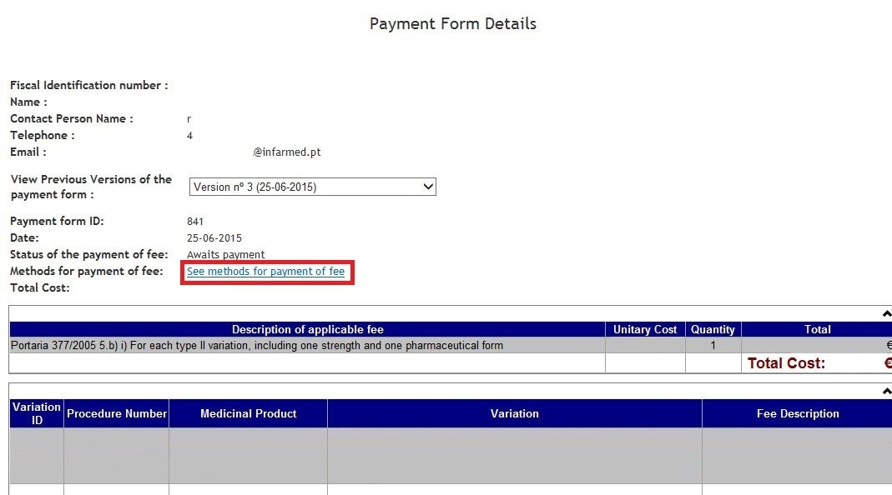

- In the following screen are shown the available payment methods. To use credit card payments click on the hiperlink “click here”

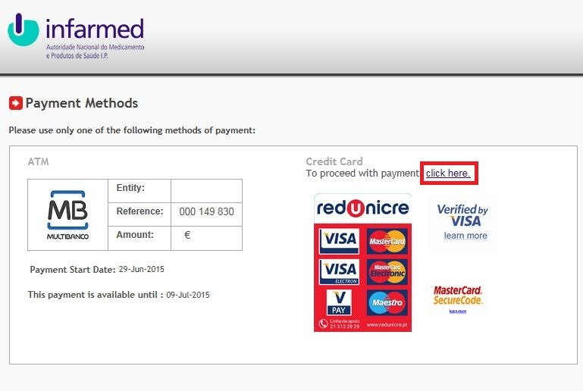

- On the last screen, fill the required information: card number, expiration date and card security code, for the credit card to be used in the payment of the fee.
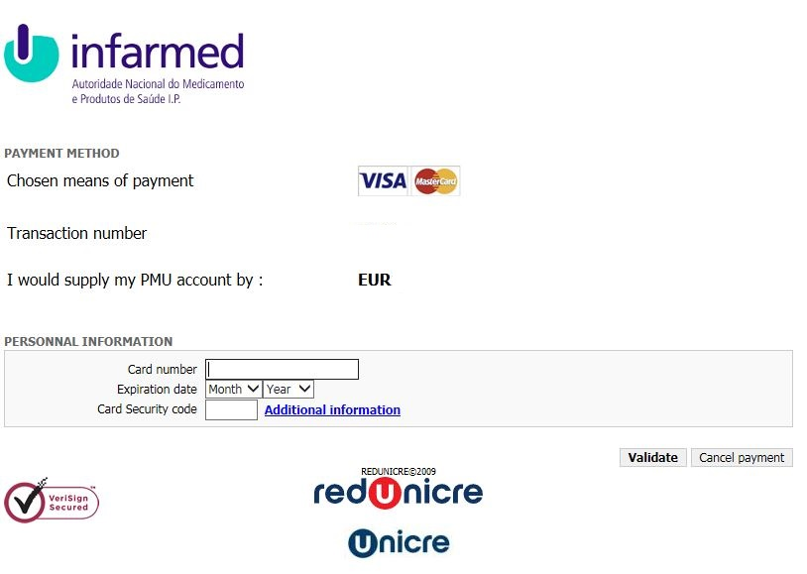

- At the end of the operation, click on Validate button.

