SMUH-AIM

Payments by credit card
SMUH-AIM electronic portal manages the payment of fees regarding pre-submission of marketing authorization applications to INFARMED,I.P.
A new functionality has been integrated to SMUH-AIM portal, which allows the payment of fees by credit card.
In the following screens, we demonstrate how to use this type of payment in SMUH-AIM portal:

- In the screen which refers to the fee payment, click on the hiperlink “See methods for payment of fee”
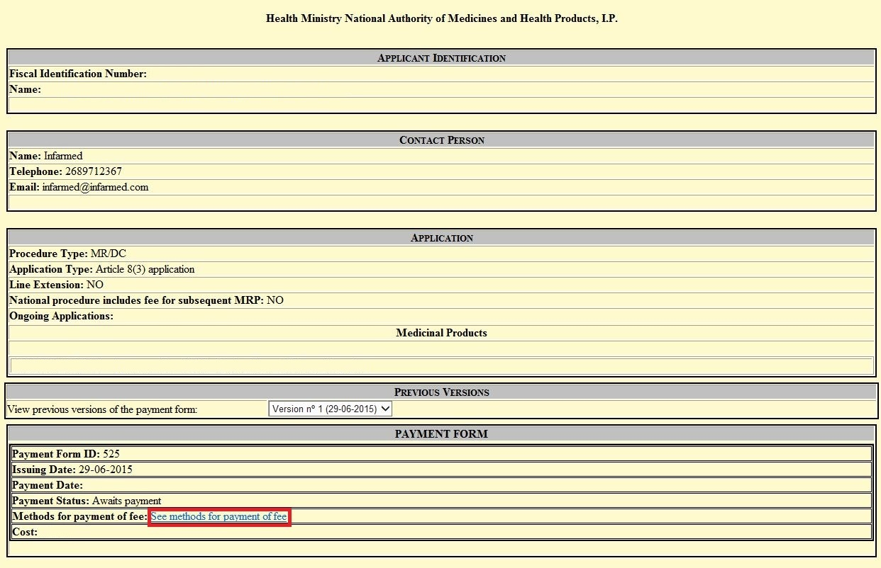

- In the following screen are shown the available payment methods. To use credit card payments click on the hiperlink “click here”

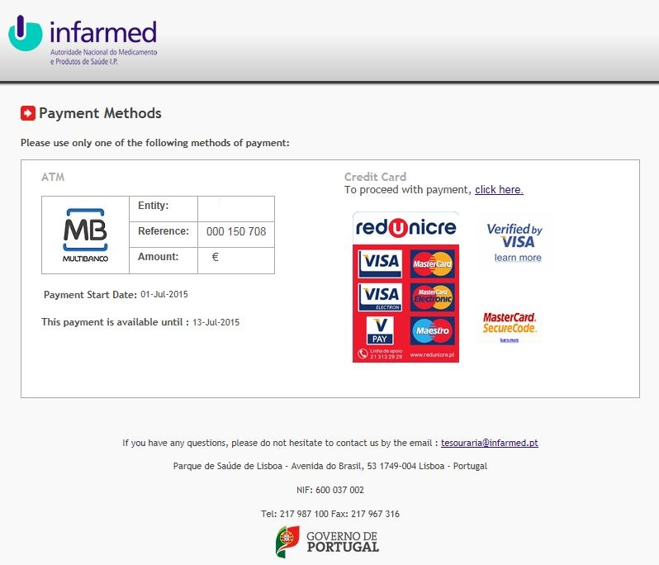

- On the last screen, fill the required information: card number, expiration date and card security code, for the credit card to be used in the payment of the fee.

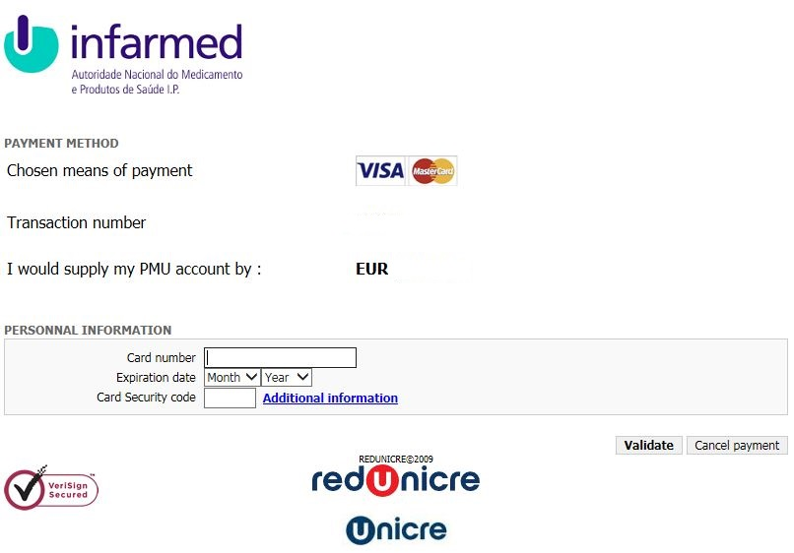

- At the end of the operation, click on Validate button.

