ELECTRONIC PRE-SUBMISSION OF MAA

(SMUH-AIM)

INSTRUCTIONS MANUAL
1. INTRODUCTION 5
1.1. Objective 5
2. REQUIREMENTS FOR USE OF THE PLATFORM 5
2.1. Login Screen 5
3. Initial Screen 6
3.1. Applicant’s Area 6
3.2. Search Area 9
3.3. Search Result Area 10
3.4. Action Area 10
4. NEW APPLICATION 11
4.1. GENERAL RULES OF FILLING THE ELECTRONIC APPLICATION FORM 13
4.2 PROCEDURE INFORMATION AREA 14
4.2.1 Procedure Type 14
4.2.2 MRP/RUP where PT – RMS 14
4.2.3 Medicinal Product 14
4.2.4 National procedure includes fee for subsequent MRP 15
4.2.5 RMS 15
4.2.6 Identification of similar procedures previously submitted 16
4.2.7 Procedure number(s) to be considered 16
4.2.8 CMS 16
4.2.9 Procedure Number 17
4.3 APPLICATION TYPE AREA 17
4.3.1 Application Type (concerning procedure legal basis) 17
4.3.2 Select the Reference Medicinal Product 18
4.3.3 Line Extension 18
4.4 MARKETING AUTHORISATION APPLICATION DEAILS 18
4.4.1 Proposed (Invented) Name 19
4.4.2 Strength 19
4.4.3 ATC Code 21
4.4.4 CFT Classification 22
4.4.5 Pharmaceutical Form 22
4.4.6 INN/Active Substance 23
4.4.7 Legal Status 24
4.4.8 Routes of Administration 25
4.5 REQUESTED PRESENTATIONS 25
4.5.1 Primary Packaging 26
4.5.2 Description 27
4.5.3 Units 28
4.5.4 Quantity 28
4.5.5 Package Condition/ Shelf-life/ Storage conditions / Temperature 31
4.5.5.1 Package Condition field 32
4.5.5.2 Shelf-life field 32
4.5.5.3 Storage conditions field 33
4.5.5.4 Temperature field 33
4.6 Qualitative and Quantitative composition (active substances and excipients) 34
4.6.1 Pharmaceutical Product 35
4.6.2 Qualitative and quantitative composition (Active substance and excipients) 35
4.6.2.1 Substance 36
4.6.2.2 Quantity and Units 36
4.6.2.3 Ingredient Type 38
4.7 Manufacturing Chain 39
4.7.1 Manufactures 39
4.7.1.1 Manufacturing Operation 40
4.7.1.2 Manufacturer (name and address) 41
4.7.2 Marketing Authorisation Holder 42
4.7.3 Qualified Person for Pharmacovigilance and Person authorised for communication on behalf of the Applicant 43
4.7.3.1 Qualified Person for Pharmacovigilance and Telephone (Qualif. Person Pharm.) 43
4.7.3.2 Person authorised for communication on behalf of the Applicant (Name, Telephone, Fax and Email) 43
4.8 documents Attachement Area 44
4.9 Statement regarding risk of transmission of spongiform encephalopathies 44
4.10 Action Buttons: Save and back 45
5. Copy an Application 46
6. Delete an Application 46
7. Change an Application Already Saved 47
8. Submitting Marketing Authorization Applications 47
8.1 Issue the payment form for new applications 47
8.2 Issue the payment form for strengths or pharmaceutical forms submitted afterwards 51
8.3 Issue payment for reference and Paying the Fee 51
9. Screen for View of application 55
10. Request for supplementary information 57
11. Procedure details 59

1. INTRODUCTION

1.1. Objective

This manual intends to put out the way of filling the electronic application form for the submission of Marketing Authorization Applications. Applicants must fill in the application form ahead of submitting the dossier.

The electronic portal allow pre-submission of marketing authorisation applications to INFARMED, I.P. by national and mutual recognition/decentralised procedures, where Portugal acts as Reference Member State or as Concerned Member State, including pre-submission of MR or Repeated Use procedures where Portugal acts as Reference Member State (for which preparation of assessment report is required previously to the European procedure).

The fulfilment of the present rules is of major importance as the quality of the information in the electronic application form depends mainly on the quality of the data inicially inserted.

The data management by Infarmed should consist only in a quality assurance mechanism and should not be understood as a systematic review of the inserted data, which would consist a doubling of efforts.

2. REQUIREMENTS FOR USE OF THE PLATFORM

Access to the External Portal is made using the link available in Infarmed’s website:
https://app.infarmed.pt/smuh_aim/frmLogin.aspx

The link opens the login page of the portal, where the appropriate credentials should be inserted by applicants.

The following minimum requirements for use of the SMUH-AIM portal are applicable:

• Hardware: at least 1 Gb of RAM memory is advised
• Software (mandatory): browser Internet Explorer 7.0 and higher in compatibility mode
• An Internet connection speed of at least 7.2 Mb/s

2.1. Login Screen
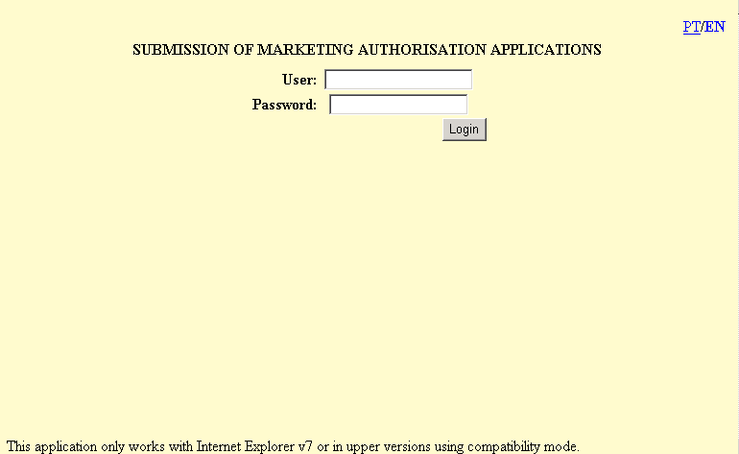
The platform is available in Portuguese and English. The language may be changed as desired by the links available at the top right of the page.

In this screen applicants have to insert their credentials for access to the platform: user (with the format gpon0000) and password, and press the button .

For more information on how to request user/password to the portal please refer to the information available in Infarmed’s website in the area Página Inicial> Medicamentos Uso Humano> Autorização de Introdução no Mercado> Novos pedidos de AIM.

Please note that the request for user and password should be submitted in the Online Registration of Users of the Electronic System for the Management of Medicinal Products of Human Use (SMUH).

Each session in the SMUH-AIM will expire after 40 minutes of inactivity in the platform.

3. Initial Screen

If the user/password are correct, the user is taken to the initial screen of the platform.
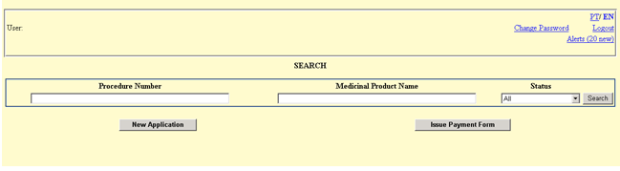

This screen consists of the following areas whose features are described below:

- Applicant’s Area
- Search Area
- Search Result Area
- Action Area

3.1. Applicant’s Area

This area includes:
- Information on the official company name indicated after ;
- A link to change the language PT or EN;
- A link to change the password to enter the portal (please refer to section “Change Password Screen” for more information on this feature);
- A link to view Alerts sent in relation to payment forms (please refer to section “Alert Screen” for more information on this feature);
- A link to exit the portal.
3.1.1. Change Password Screen

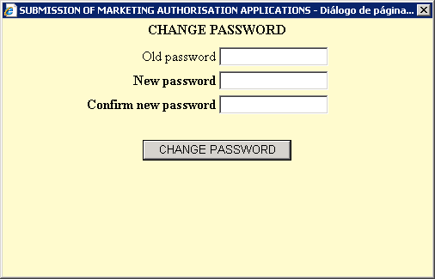

This screen is accessed via the link in the Applicant’s Area of the Initial Screen, and allows the applicant to change the password for accessing the SMUH-AIM portal.

The same credentials (user/password) are used to access the following portals:
- SMUH‐AIM for pre‐submission of Marketing Authorisation applications, including the portal for information on the status of MA applications (national procedure only).
- SMUH‐ALTER for submission of variations to existing Marketing Authorisations.
- Application for confirmation/update of manufacturing flow chart of a medicinal product.
- Information on the status of reimbursement application.

As such, if the password is changed in SMUH-AIM, it is also changed in the other platforms.

The current password must be entered in the “Old password” field, and the new one must be entered in the “New password” and “New password (confirm)” fields.

After pressing the button , a message for confirmation of change of passowrd will be viewed.

3.1.2. Alert Screen

This screen can be accessed via the link in the Applicant’s Area of the Initial Screen. It shows alerts sent in relation to payment forms.

The link to access the screen shows whether there are unread alerts (once the details of an alert have been viewed, it is considered as read).

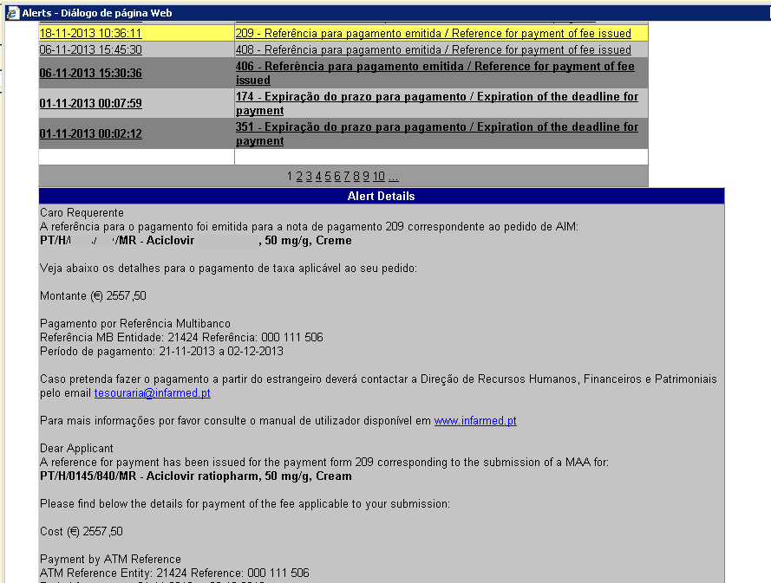

This screen is comprised of two areas: the first shows the list of alerts sent to the applicant, and the second shows the detail of the alert selected in the first area.

This list of alerts is comprised of the following fields:
- Alert Date - date on which the alert was issued to the applicant;
- Alert - contains information on the subject of the alert and ID of the corresponding payment form.

Alerts may be sorted by date or subject by pressing the links available in the columns “Alert Date” and “Alert”, respectively. Also, sorting the list by “Alert” will list the alerts by number of payment form which facilitates the identification of all alerts issued for a single payment form.
After clicking on the link, the “Alert Date” field or the “Alert” field, the alert will be highlighted in yellow and the description of the alert will be shown in the the “Alert Details” field.

For each alert, an email with the same information as the alert is also sent to the email address given by the applicant in the Contact Person area of the Issue Payment Form Screen.

Alerts will be displayed/sent by email in the following situations:

- “Reference for payment of fee issued”: it will be received by the applicant after the reference for payment has been issued for the payment form (or correction of the payment form resulting in additional fee required). This alert includes information regarding the fee to be paid, ATM Reference and the period for payment. Further to receipt of this alert, the “Status” of all applications included in the payment form will be changed to “Awaits payment”.

- “Expiration of the deadline for payment”: it will be received by the applicant after expiration of the period for payment, without payment being performed or without payment reconciliation by the payment gateway. After receipt of this alert the “Status” of all applications included in the payment form will be changed to Missing payment of fee. In order to proceed with the required payment of fee (and revert this status), and provided thatthere hasn´t been any previous payment for the same application, the applicant must return to the View of the Note for Payment Sreen and press the button 'Issue Payment Reference' to issue the new ATM reference. If there has already been a previous payment, the applicant must request Infarmed to issue new details for payment.

- “Refund of fee in progress”: it will be received by the applicant after correction of the payment form by Infarmed, when the total fee referred in the amended payment form is lower than the fee already paid. This alert will inform the applicant that Infarmed has corrected the payment form previously validated and that a refund of fee is being processed.

- “Refund of fee concluded”: it will be received by the applicant after confirmation of conclusion of the processing of refund of the fee by the payment gateway. This alert includes information regarding the amount refunded and also the date/time of conclusion of the refund process.

3.2. Search Area

This area allows marketing applications entered in the platform to be searched, whether in the status of being filled in or submitted.

The following search criteria are available:
- Procedure Number
- Medicinal Product Name
- Status

To perform a search using any of the criteria shown above, or using various criteria simultaneously, the user should:
- In the case of free text fields, enter the value or part of the value to be searched, or using the % character in accordance with the rules below:
. X or X%: returns all results beginning with X;
. %X: returns all results containing X;
. This search does not take into account whether the name of the medicinal product to be searched is in upper case/lower case letters.

- Select from the list the value to be searched, in the remaining fields.
- Press the button to start the search.

The MAA submitted in the portal before 21 October 2013 can still be searched in this screen.
However, the new search criteria (“Procedure number”) can only be used to search MAA applications submitted after 21 October 2013.

The following selection options are available for the search by “Status”:

- All: by default, which returns all results regardless of the status of the application;
- Filling in progress: an application being created in the platform (not yet submitted);
- Issue Payment Details: an application being created on the online platform for which the filling online form is completed and the payment form was generated, and is waiting to issue payment reference. It is possible to return to the status ‘Filing in progress’ by canceling the payment form generated;
- Awaits payment: status after issuing of the ATM reference for payment and before payment reconciliation;
- Payment of fee valid: after payment reconciliation (NOTE: in case of applications exempted from payment of fees , i.e. the payment form validated by Infarmed indicates total cost of 0,00€, the status of the procedure will be changed immediately to Payment of fee valid);
- Missing payment of fee: after exceeding the payment period without payment reconciliation;
- Submited: after the MAA has been submitted by the applicant at Infarmed and the respective validation by Infarmed;
- Validate Payment: this state is not available for MAA submitted after 21st October 2013;
- Confirm Payment: this state is not available for MAA submitted after 21st October 2013;
- Refused: this state is not available for MAA submitted after 21 October 2013.

The MAA (i.e. the dossier) should only be submitted to INFARMED, I.P. after eletronic pre-submission of the application in SMUH-AIM and validation of payment of fee (confirm in the portal by procedure status “Payment of fee valid”).

3.3. Search Result Area

This area is filled in after pressing the button in the Search Area, and lists the applications created by the applicant, based on the search criteria selected in the Search Criteria area.

The search result area is comprised of the following fields in the following order:

- Delete (the column name is not displayed in the heading)
- Select
- Procedure Number
- Medicinal Product Name
- Pharmaceutical Form
- Strength
- Submission Date
- Status
- Payment Form
- Copy Application (the column name is not displayed in the heading)
- Validate Request (the column name is not displayed in the heading)
- Request for supplementary information
- Procedure details

The links "Procedure Number" and "Medicinal Product Name" allow the applicant to access the Screen for Creation of the Application or the Screen for View of the Application depending on wether the application is in the status "Filling in progress" or in a status different from "Filling in progress".

It is possible to navigate in the several results pages, pressing the links <1 2 3 …>, which are available when the list includes more that one page of results.

3.4. Action Area

In this Area, the applicant can:
- Create a new application for MAA by pressing the button . The applicant must fill in the online application form according to the rules described in Section 4. New Application.

- Issue the payment form and submit the application by pressing the button  . This is only possible for applications whith online forms completed and validated. The issuing of the payment form and subsequent related actions are described in Section 8. Submitting Marketing Authorization Applications .

4. NEW APPLICATION

This screen consists of an online form, to be filled by the applicant with regard to administrative information of a MAA.

This screen consists of the following areas:

- Applicant’s Area
- Procedure Information Area
- Application Type Area
- Marketing Authorisation Application Details Area
- Container Area
- Qualitative and quantitative composition (Active substance and excipients) Area
- Manufacturers Area
- Documents Area
- Action Area

All the information on this screen is available in Portuguese and English, and is displayed in the language selected in the Initial Screen.
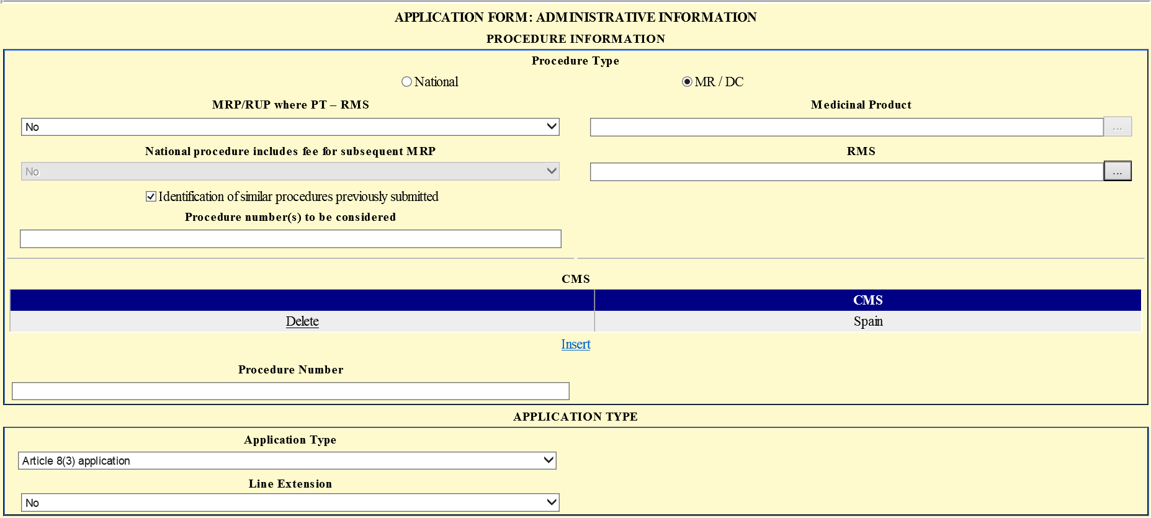

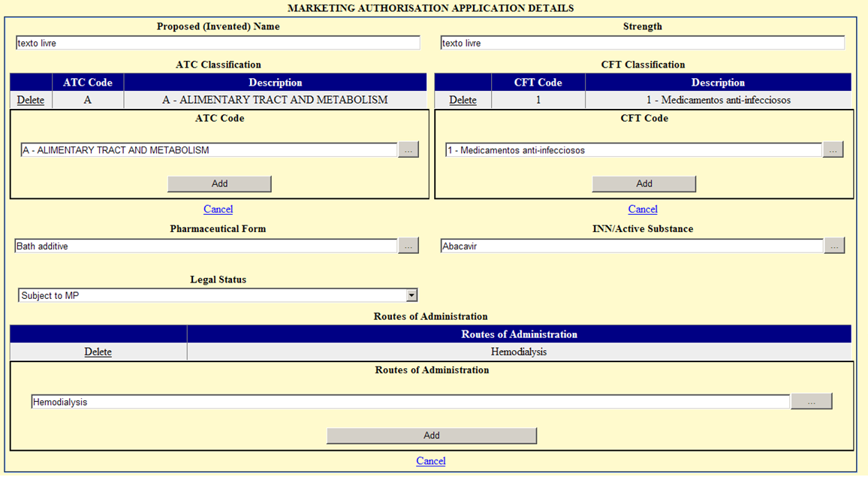

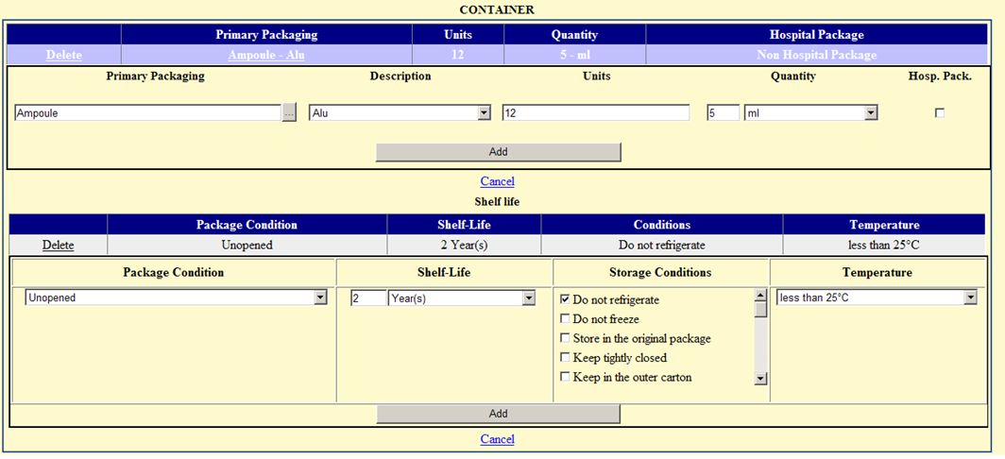
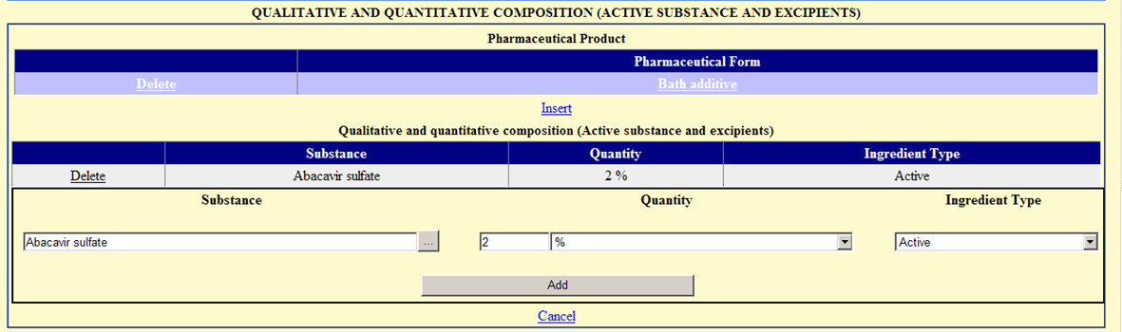
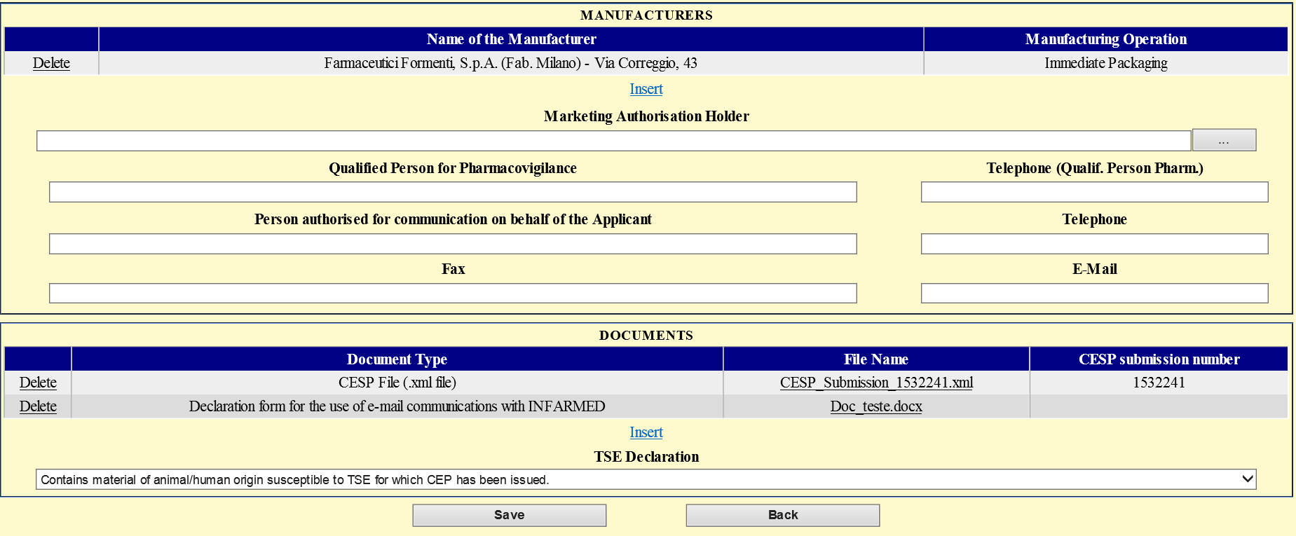

4.1. GENERAL RULES OF FILLING THE ELECTRONIC APPLICATION FORM

(Text fields)

* Write the first letter of each word with upper case letter and the remaining ones with small letters.
* Do not leave more than one space between each word.
* To writte the greek letter "µ" (micro) push down the key "Alt" and while pressing this key write "0181".

(Selection fields)

* The fields consist of pre-defined list from which a selection has to be made (they are not free text fields).
Finding a term is done by writing part of the intended term and selecting between the options presented. Results show all the existing terms with the sequence of letters, independently from where they stand in the word. You should restrict your search as much as possible.

E.g.: if you search for a the pharmaceutical form by writing %oral, all pharmaceutical forms containing oral will be shown ( see 4.4 Marketing Authorization Application Details – 4.4.5 pharmaceutical form.

Lists for selection of entities
E.g.: MA Holder, manufacturers

ATTENTION: If the intended entity is not found on the list, send a request to Infarmed via email entidades@infarmed.pt, to include it in the list, along with relevant documentation and identifying the MAA. If the entity required is a manufacturer one of the following three documents must be submitted: Certificate of GMP, CEP or Manufacturing Authorisation. If the requested entity is a future marketing authorisation holder it is necessary to attach copy of Company Register Information.

Lists for the selection of substances
E.g. Qualitative and quantitative composition in terms of the active substances and the excipients

ATTENTION: If the intended substance is not found on the list, ask Infarmed to include it via email substancias@infarmed.pt, along with the monography of the substance and identifying the MAA.

Lists for selection of INN

ATTENTION: If the intended INN is not found on the list, ask Infarmed to include it via the email substancias@infarmed.pt, indicating the INN in EN and PT. Attach to the email the proposed SmPC associated with the application and identify the MAA.

Lists involving selection of Standard Terms
Pharmaceutical Form (medicine); Pharmaceutical Form (pharmaceutical product); Primary packaging; Route of administration.

4.2 PROCEDURE INFORMATION AREA

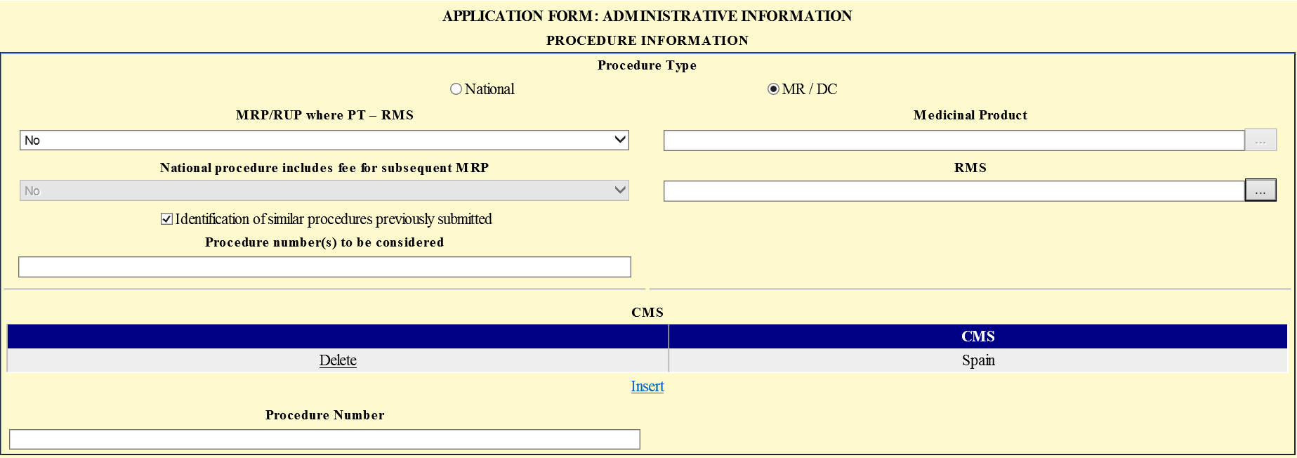

4.2.1 Procedure Type
( radio-button fields)

It should be indicated the procedure type applicable to the MAA being submitted (National or Mutual Recognition / Decentralised).
Depending on the selection made it may or may not be necessary to fill in the remaining fields in this area.
After the application is successfully saved the first time, this field is locked for editing.

4.2.2 MRP/RUP where PT – RMS
(field with list of values "Yes" and "No”)

Available only if the “MR / DC” field in Procedure Type is selected.
It should be selected the value "Yes" or “No" in the selection list displayed in this field.
The value "Yes" should be selected only in the case of application for Mutual Recognition Procedure or Repeated Use procedure with Portugal as RMS, for which preparation of assessment report is required previously to the European procedure.

After the application is successfully saved the first time, this field is locked for editing.

4.2.3 Medicinal Product
(selection field)

Available only if it is selected the “MR / DC” field in Procedure Type and the value "Yes" in the field “MRP/RUP where PT – RMS”.

It should be selected the medicine for whichthe applicant holds a marketing authorisation granted by INFARMED, I.P. and for which the application for MRP / Repeated use with PT as RMS is being submitted.

* Click . In the new window write the Medicinal Product name and click .

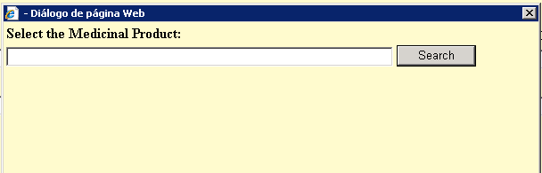

* From the resulting list select the intended Medicinal Product by clicking on the corresponding line.

* The Medicinal Product is shown in the main window.

4.2.4 National procedure includes fee for subsequent MRP
(field with list of values ​​"Yes" and "No”)

Available whether you choose either the option “National” or “MR / DC” in Procedure Type field.
It should be selected the value "Yes" or “No" in the selection list displayed in this field.

The option "Yes" should only be selected if:
- The application refers to a national procedure for which the applicant intends to pay fee for future submission of a mutual recognition procedure for the same MA.
- The application refers to a mutual recognition procedure in which PT is RMS, and the applicable fee was paid upon submission of the application for marketing authorization by national procedure. In this case the Proof of payment of fee must be attached to the online form.

After the application is successfully saved the first time, this field is locked for editing.

4.2.5 RMS
(selection field)

Available only if the “MR / DC” button in the Procedure Type field is selected.
It should be selected, from the selection list available, the country that will act as Reference Member State.

ATTENTION: the option Portugal will be selected by default, if "Yes" was selected in the MRP / Repeated use with PT as RMS field.

* Click . In the new window write the RMS country name and click .

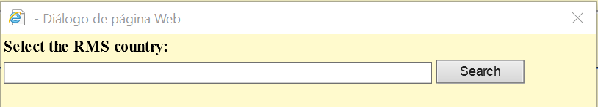

* From the resulting list select the intended RMS country by clicking on the corresponding line.

* The RMS country is shown in the main window.

4.2.6 Identification of similar procedures previously submitted
(selection field)

It should be selected if there is an intention to identify one or more procedures previously submitted that are similar to the procedure that is now being submitted.

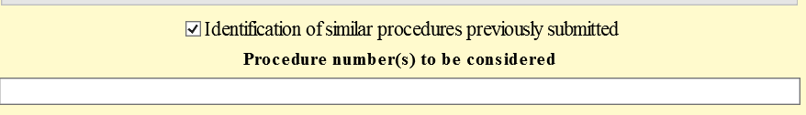

4.2.7 Procedure number(s) to be considered
(text field - 150 characters)

Mandatory field if the checkbox of the field “Identification of similar procedures previously submitted” has been selected.
All previously submitted procedures that are similar to the procedure that is now being submitted.
If more than one procedure number is entered, the different procedure numbers must be separated by a semicolon (;)

4.2.8 CMS
(selection field)

Available only if the “MR / DC” button in the Procedure Type field is selected.
It should be selected, from the selection list available, the country or countries that will act as Concerned Member State(s).
This field allows the selection, addition and removal of countries from the CMS list.

* Select the key and click afterwards. In the new window write the intended country name and click .

* From the resulting list select the intended Country by clicking the corresponding name.

* The Country is shown in the main window. Click .

* To cancel Insertion of the CMS Countries click .

* The inserted Countries can be removed from the list afterwards using the key .

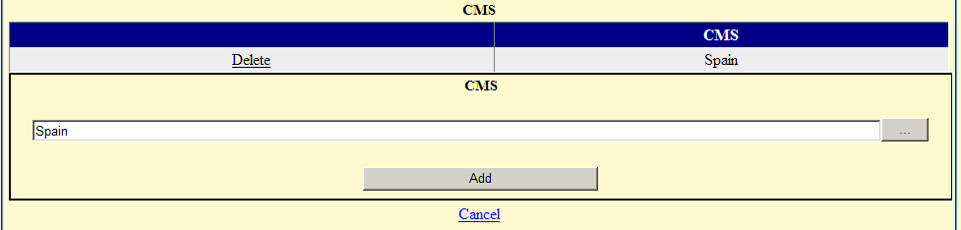

4.2.9 Procedure Number
(selection field)

Available only if the “MR / DC” button in the field Procedure Type is selected.
The rules for awarding Procedure numbers in the MRP/DCP should be respected.

4.3 APPLICATION TYPE AREA

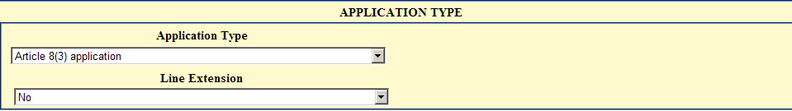

This area consists of the fields described below:

4.3.1 Application Type (concerning procedure legal basis)
(selection field)

Content of the table:
* This list is in accordance with the legal basis of new MAA as defined in Directive 2001/83/CE

* The optins are:
Article 8(3) application
Article 10(1) Generic application
Article 10a well-established use application
Article 10b fixed combination application
Article 10c informed consent application
Article 10(3) hybrid application

If the legal basis selected is generic, hibrid or informed consent, the reference medicine or the original medicine must be filled in the "Select the Reference Medicinal Product" field.

4.3.2 Select the Reference Medicinal Product
(selection field)

This field is visible only if the option "Article 10(1) Generic application", "Article 10(3) hybrid application" or "Article 10c informed consent application " is selected in the field "Type of Request".

ATTENTION: In this field the Reference Medicinal Product should be selected from the available medicine list. If the Reference Medicinal Product is not authorized in Portugal the option "Other medicinal product not authorized in Portugal" should be selected.

* Click . In the new window write the Reference Medicinal Product name, click and select the intended option.

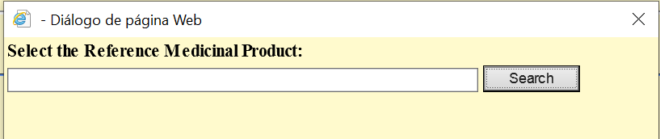

* From the resulting list select the intended Reference Medicinal Product name by clicking on the corresponding line.

* The Reference Medicinal Product name is shown in the main window.

4.3.3 Line Extension
(field with list of values ​​"Yes" and "No”)

* Should be indicated if the application is a line extension using the options "Yes" or "No".

4.4 MARKETING AUTHORISATION APPLICATION DEAILS

In this area the applicant can fill in the information regarding the marketing authorisation application details.

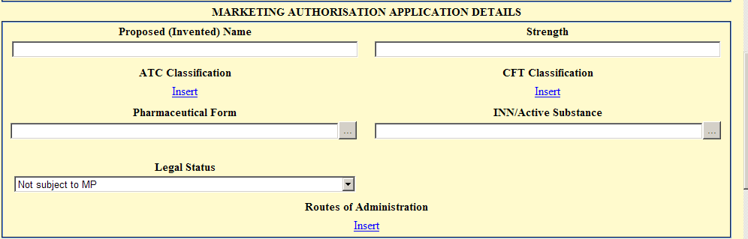

This area consists of the following fields / subfields:

- Proposed (Invented) Name
- Strength
- ATC Classification
- CFT Classification
- Pharmaceutical Form
- INN / Active Substance
- Legal Status
- Routes of Administration

4.4.1 Proposed (Invented) Name

Filling in:
(text field - 80 characters)

* Put the cursor in the begining of the text field (do not leave any space).

* Write the first letter with upper case letter and the next ones with lower case letters.

* If the proposed invented name is composed by two names, start each word with upper letter.

ATTENTION: Strength and pharmaceutical form of the medicinal product should not be referred in this field.

4.4.2 Strength

Use:
* Use this fied to fill in the quantitative composition in terms of the active substance by pharmaceutical unit, expressed in INN.

Filling in:
(text field – 30 characters)

* Put the cursor in the beginning of the field (do not leave any space).
* Leave one and no more than one space between the quantity and the unit of measurement.
Correct: 15 mg
Incorrect: 15 mg or 15mg
* Use dots and not commas, without leaving any space between figures.
Correct: 1.5 mg
Incorrect: 1, 5 mg
* The active substance quantity should be expressed in INN.
Correct: INN/quantity – Amoxicilin – 500 mg
Incorrect: Active substance /quantity – Amoxicillin trihydrate – 574 mg

Filling the field Strength fordifferent Pharmaceutical Forms

 | Strenght
Single-dose solid pharmaceutical forms  Capsule, Tablet, Lozenge, Cachet; Suppository  (blister; strip; Sachet; Tablet container etc.) | Total of the active – mass  20 mg
Multi-dose solid pharmaceutical forms  Granules  (in bottle) | Concentration of the active substance – mass/mass  50 mg/g
Singe-dose liquid pharmaceutical forms  Eye drops, solution, solution for injection, oral solution  (ampoule, sachet, vial) | Quantity of the active substance in the adminstered volume – mass/adm. volume  25 mg/5 ml
Multi-dose liquid pharmaceutical forms  Syrup, Oral solution, eye drops, solution  (in bottle) | Concentration of the active substance – mass/total volume  500 mg/ml
Single-dose semi-solid pharmaceutcal forms  Cream, paste, ointment, gel  (cannula, tube) | Quantity of active substance in the administered mass – mass/ adm. mass  20 mg/5 mg
Multi-dose semi-solid pharmaceutical forms  Cream, paste, ointment, gel  (cannula, tube) | Concentration of the active substance – mass/mass  50 mg/g
Concentrates  Concentrate for solution for injection | Concentration of the active substance before dilution – mg/ml  20 mg/ml
Impregnated dressing, implanter, Intrauterine delivery system and Transdermal system | Preferred -> Medim strengh per unit time  50 mg/24 h
Aerosol | Preferred -> Quantity of active substance per dose  50 µg/inalação
Powders for reconstitution (single-dose)  With reconstituition volume  Without reconstituition volume or variable reconstitution volume | Quantity of the active substance in the administered vomune – mass/adm. volume  50 mg/10 ml  Total of active substance – mass  50 mg
Powders for reconstitution ( multi dose)  With reconstituition volume  Without reconstituition volume or variable reconstitution volume | Concentration of active substance – mass/total volume  5 mg/ml  Total of active substance – mass  50 mg

Associations:
* When the medicinal product has more than one active substance, the above rules should be applied to each active substance following the same order mentioned in the INN. In this case try to use, whenever possible, the same unit for both substances.
* The dosage of each substance should be separated by space+space.
* When is not possible to express the strengths according to the previous rules use the term "Association". Do not abbreviate the dosage eliminating spaces or using another symbology.

Correct: 150 mg/ml + 0.15 mg/ml
Incorrect: 150 mg/ml + 150 x 10⁻³ mg/ml
Incorrect: 150 mg/ml + 0.150 mg/ml
Incorrect: 150 mg/ml +150 μg/ml
150 mg/ml + 0.15 mg/ml + 350 mg/ml + 6.15 mg/ml If does not fit – Replace by “Association”

Combined Pharmaceuticals Forms:
* The strenght of each pharmaceutical form should be expressed between brackets. Observe inside each brackets the rules above.
* The interpretation of these cases may be unclear. See the examples below:

Pharmaceuticals Forms | Strength |  | INN
Pharmaceuticals Forms | P. Form 1 | P. Form. 2 | INN
Coated tablet | (A) + (A)  (25 mg) + (100 mg) |  | A  Quetiapine
Coated tablet + Tablet | (A) + (B)  (1,25 mg) + (5 mg) |  | A + B  Conjugated oestrogens + Medrogestone
Film - coated tablet | (A) + (A + B)  (2 mg) + (2 mg + 0,05 mg) |  | A + B  Estradiol + Gestodene
Coated tablet | (A + B) + (B)  (20 mg + 2 mg) + (2 mg) |  | A + B  Dydrogesterone + Estradiol

4.4.3 ATC Code

Searching and filing in
(selection field)

ATTENTION: Several ATC codes can be selected for the same medicine.

* Select the key and click afterwards. In the new window write the ATC code and click .

The ATC code is made of different levels represented by capital letters and numbers. Do not leave any space betwenn the letters and numbers. E.g.: D07AA01

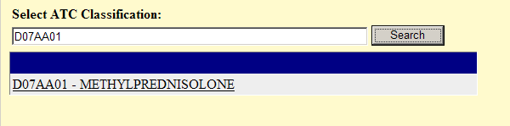

* Select from the resulting list the intended ATC code.
* The ATC code is shown in the main window,. Click .

* If the ATC code is not found, choose an upper level code.
E.g: If the code A01AA03 cannot be found choose A01AA.

* To cancel inserting the ATC code click .

* The inserted ATC code can be removed afterwards using the key .

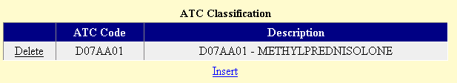

4.4.4 CFT Classification

Searching and filing in:
(Selection field)

ATTENTION: Several CFT codes can be selected for the same medicine. CFT stands for Classificação Farmaco-Terapêutica and is a national pharmaco-therapeutical classification.

* Select the key and click afterwards. In the new window write the CFT code and click .

The CFT code is made of numbers separated by dots, without space between them.
E.g.: 3.4.2.2

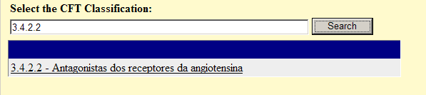

* Select from the resulting list the intended CFT code.

* The CFT code is shown in the main window. Click .

* To cancel inserting the CFT code click .

* The inserted CFT code can be removed afterwards using the key .

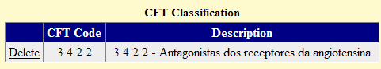

4.4.5 Pharmaceutical Form

Selection list content:
* "STANDARDS TERMS - Pharmaceutical dosage forms" - European Pharmacopoeia.

Searching and filing in:
(Selection field)

ATTENTION: Only one Pharmaceutical Form can be selected per medicine.

* Click the key . In the new window write the pharmaceutical form. Click .

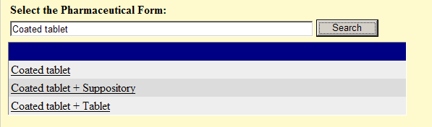

* Select from the resulting list the intended pharmaceutical form.

* The pharmaceutical form is shown in the main window.

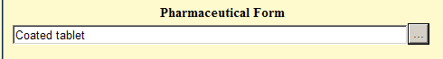

4.4.6 INN/Active Substance

* Information regarding the INN of the medicine’s active substances.

Searching and filing in:
(Selection field)
* When the medicine has more than one active substance the combined term for the active substances shoud be used.

ATTENTION:
- Only one INN/combined INN can be selected per medicine.
E.g.: Ciproterone + Ethinylestradiol should be used instead of Ciproterone and Ethinylestradiol alone.

- If the intended INN/Combined INN is not found on the list, ask Infarmed to include it via the email substancias@infarmed.pt, indicating the INN in EN and PT. Attach to the email the proposed SmPC associated with the application and identify the MAA.
In case of urgency in the submission of the application, select the option “Others” available in selection list.

- In the case of homeopathic medicines always select the option “Others”.

* Click the key . In the new window write the INN/combined INN and click .

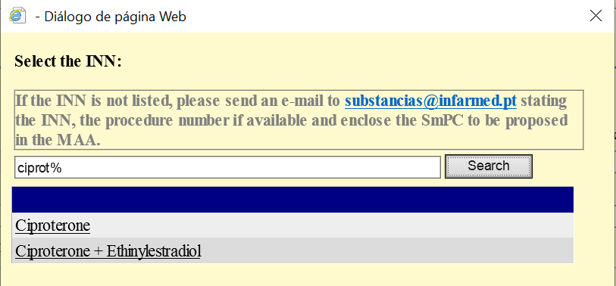

* Select from the resulting list the intended INN/combined INN.

* The INN/combined INN is shown in the main window.

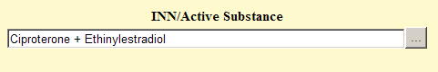

4.4.7 Legal Status

* The list is based on the Decreto de Lei n.º 176/2006 de 30 de Agosto, in its current writing.

Filling in:
(selection field)

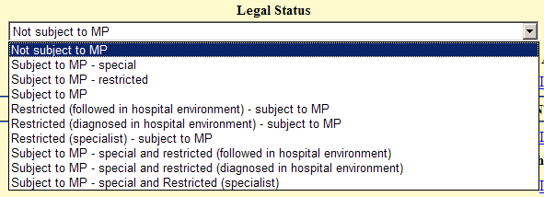

* Choose from the available list the aplicable Legal Status.

ATTENTION: Only one Legal Status can be selected per medicine.

4.4.8 Routes of Administration

Table content:
* STANDARDS TERMS – Routes of Administration" - European Pharmacopoeia.

Searching and filling in:
(selection field)

ATTENTION: Several Routes of Administration can be selected for the same medicine.

* Click the key and click afterwards. In the new window write the route of administration and click .

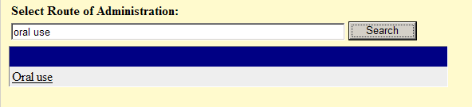

E.g..: As mentioned above the search should be as strict as possible. If “Intradermal use” was the intended administration route the search term should be “%intradermal”.

* Select from the resulting list the intended route of administration.

* The route of administration is shown in the main window. Click .

* To cancel inserting the route of administration click .

* The inserted route of administration can be removed afterwards using the key .

4.5 REQUESTED PRESENTATIONS

In this area the applicant can fill in the information on the packages included in the application for marketing authorization, in terms of type of container and pack size.

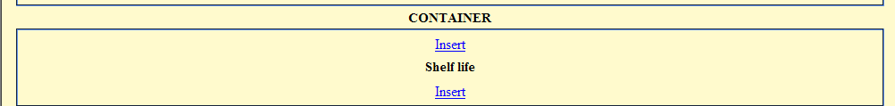
This area consists of the following subareas:
• Packages
• Shelf life of the packages
To fill these subareas press the respective links .

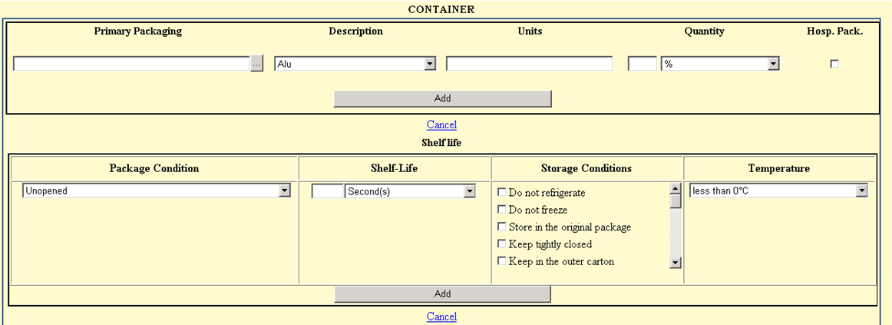

The subarea "Shelf life" is related to the subarea "Container". To associate a shelf life to a container, the container should be selected in the subarea "Container" for which you want to insert the respective shelf life in Subarea "Shelf life".

“Container” subarea consists of the following fields:
- Primary Packaging
- Description
- Units
- Quantity
- Hospital Package

“Shelf-lile” subarea consists of the following fields:
- Package Condition
- Shelf-Life
- Storage Conditions
- Temperature

ATTENTION: For each package the condition “unopened” must be entered, and no more than one “unopened” condition should be added.

The filling of these fields is described below.

4.5.1 Primary Packaging

Selection list content:
* "STANDARDS TERMS - Containers" - European Pharmacopoeia.

Filling:
(selection field)
* Allways indicate the primary packaging (E.g.: blister).

* In case of medicines for reconstituition, for which there is more than one recipient within the secondary packaging, the primary packaging to be indicated should be the one containing the active substance.

* When the active substances are in more than one recipient, the primary packaging to be described should be the one needing more information (fields) to be well defined. The remaining information will be validated by Infarmed an included in the database afterwards after submission.
* Select the key and click afterwards. In the new window write the primary packaging and click .

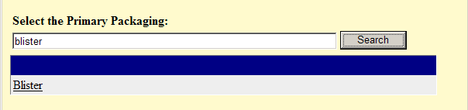

* Select the primary packaging from the list.

* The primary packaging is shown in the main window. Click .

4.5.2 Description

Filling:
(selection field)

* Indicate the type of primary packaging material, from the selection list available in this field.

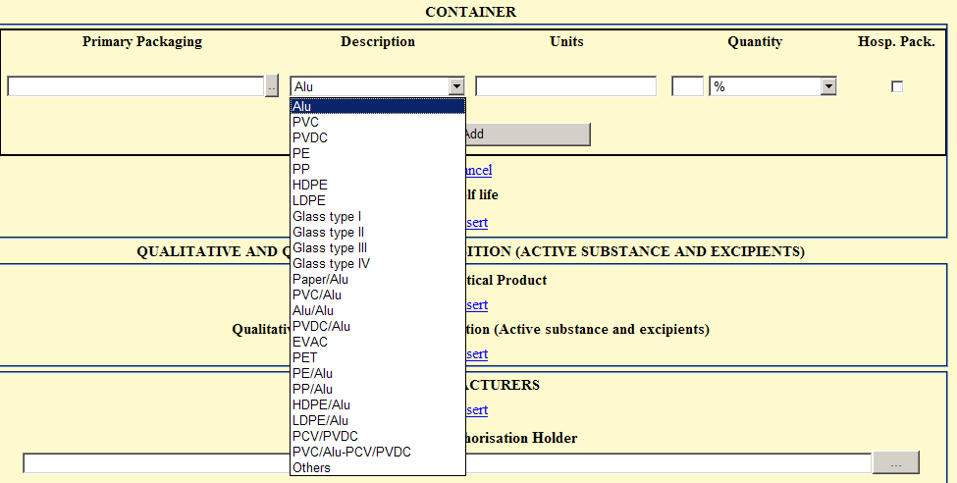

Material | Abbreviations
Aluminium | Alu
Polivinil chloride | PVC
Polivinilidene chloride | PVDC
Polyethylene | PE
Polypropylene | PP
High density Polyethylene | HDPE
Low density Polyethylene | LDPE
Type I glass | Glass type I
Type II glass | Glass type II
Type III glass | Glass type III
Type IV glass | Glass typeIV
Paper + Aluinium | Paper/Alu
PVC + Aluminium | PVC/Alu
Aluminium + Aluminium | Alu/Alu
PVDC + Aluminium | PVDC/Alu
Vinyl polyacetate | EVAC
Politereftalato ethylene | PET
Polyethylene + Aluminium | PE/Alu
Polypropilene + Aluminium | PP/Alu
High density Polyethylene + Aluminium | HDPE/Alu
Low density Polyethylene + Aluminium | LDPE/Alu
PVC + PVDC | PCV/PVDC
PVC + Aluminium e PVC + PVDC | PVC/Alu-PCV/PVDC
Others | Others

E.g.: PVC/Aluminium blister
Description: PVC/Alu

4.5.3 Units
(numeric field)
* In this field it should be ALWAYS indicated the number of units in the container.

4.5.4 Quantity

Filling:
(numeric field / selection field)

* For the correct filling of this field the recommendations contained in the table below should be considered.

Filling of the Container field according with the differents pharmaceutical form

 | Packagings
Single-dose solid pharmaceutical forms  Capsule, tablet, lozenge, Cachet; Suppository  (In blister; strip; Sachet; Tablet container etc.) | Number of units  Quantity – in white  
Multi-dose Solid pharmaceutical forms  Granules  (In bottle) | Number of units  Quantuty – total mass  E.g.  Units 1  Quantity 250 g  
Single-dose liquid pharmaceutical forms  Eye drops, solution , solution for injection, oral solution  (in ampoule, sachet, ,single-dose container, vial) | Number of units  Quantity – volume of liquid  E.g.  Units 10  Quantity 1ml  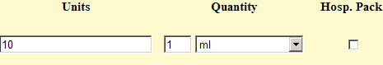
Multi-dose liquid pharmaceutical forms  Syrup, oral solution, Eye drops, solution  (In bottle) | Number of units  Quantity – volume of liquid.  E.g.  Unit 1  Quantity 150 ml  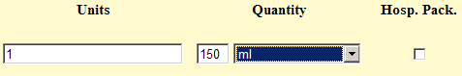
Single-dose semi-solid pharmaceutical forms  Cream, paste, ointment, gel  (In cannula, tube) | Number of units  Quantity – total mass  E.g.  Units 2  Quantity 1 g  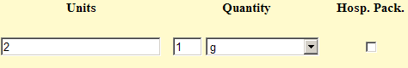
Multi-dose semi-solid pharmaceutical forms  Cream, paste, ointment, gel  (In cannula, tube) | Number of units  Quantity – total mass  E.g.  Units 1  Quantity 10 g  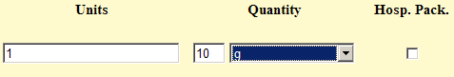
Concentrates  Concentrate for solution for infusion | Number of units  Quantity – volume of liquid  E.g.  Units 10  Quantity 2 ml  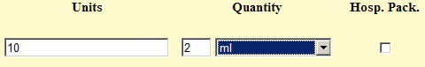
Impregnated dressing, implant, Intrauterine delivery system e transdermal system | Number of units  Quantity – in white  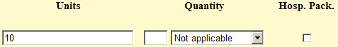
Aerosols | Number o units  Quantity – number of inhalations or, if unknown,  volume of liquid (in case of solutions)  E.g..  Units 1  Quantity 200 doses  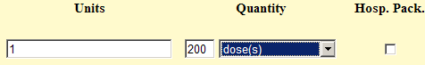
Powders for reconstitution (single-dose)  - With reconstituition volume  - Without reconstituition volume | Number of units  Quantity –reconstitution volume./ solvent volume  E.g..  Units 10  Quantity 2 ml  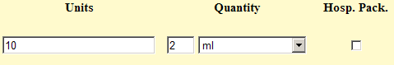  Number of units  Quantity – in whyte
Powders for reconstitution (multi-dose)  - With reconstituition volume  - Without reconstituition volume | Number of units  Quantity – reconstitution volume/ solvent volume  E.g.  Units 1  Quantity 150 ml  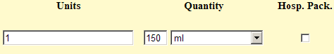  Number of unitsQuantity – in whyte
Powders for reconstitution  - With variable reconstitution volume  E.g..: variable volume of 6 ml | Number of units  Quantity – in whyte

* The field "Hosp. Pack." should be selected if the indicated container is for hospital use.

ATTENTION: After filling the applicable fields in this area, click to finish filling the information on the packaging.

* To cancel inserting the presentation click .

* To remove the presentation inserted click .

4.5.5 Package Condition/ Shelf-life/ Storage conditions / Temperature

ATTENTION:
- To fill in these fields it is first necessary to select the corresponding primary packaging material (this will show in violet). The selection is made by clicking the link present in the column headed Primary Packaging (underlined in the main window).

- The main window shows information about the selected package in the primary packaging line. Selecting another package will show the information inserted for the newly selected package.

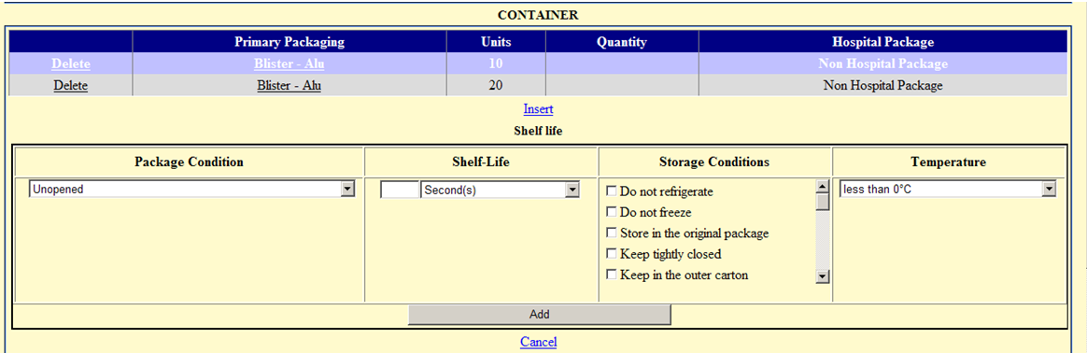

* To enter information on shelf life and storage conditions, select the button , fill in each field described below and then click .

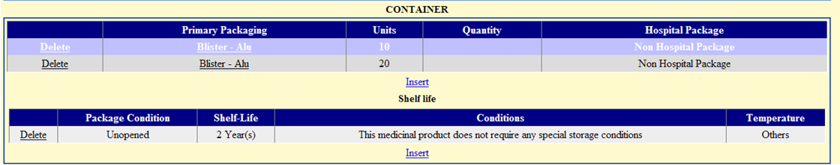

* To cancel inserting the shelf life and storage conditions click .

* The inserted shelf life and storage conditions can be removed afterwards using the key .

4.5.5.1 Package Condition field

Selection list content:
* The options are:
a) Opened - if the shelf life after opening is mentioned
b) Unopened - mandatory option.
c) Reconstituted –when the shelf life after reconstitution/dilution is mentioned in case of pharmaceutical products for reconstitution / dilution,

Filling in:
(selection field)

* For each package different package status may be described.

ATTENTION: For each package the condition “unopened” must be entered, and no more than one “unopened” condition should be added.

4.5.5.2 Shelf-life field

Use:
* It should be noted the helf-life of the medicine according with the rules established for the reference of the shelf life in SmPC (Guideline on the summary of product characteristics).

Filling in:
(numeric field /selection field)

* Write the numeric value of the shelf-life.

* In the second field choose from the available list the temporal unit.
E.g..: shelf-life 3 years
Field number - 3
Time measure unit – years

ATTENTION: The shelf life of a medicine should be expressed as: 1 month, 6 months, 1 year, 18 months, 2 years, 30 months, 3 years, 40 months, 4 years, 54 months, 5 years, ignoring other time units provided in the list.

4.5.5.3 Storage conditions field

* It must be specified storage conditions applicable to the container/package condition state that is being entered (if applicable).

Filling in:
(multi selection field)

* From the selection list and according with the recommendations on the Note for guidance on declaration of storage conditions:

Do not refrigerate
Do not freeze
Store in the original package
Keep tightly closed
Keep in the outer carton
Controlled and validated aseptic conditions
Store protected from moisture
Store protected from light
Store protected from X rays
Store protected from heat
Store and transport frozen
Store and transport refrigerated
Store in a cool place
Store in a dry place
Store in a freezer
Store in a refrigerator
Do not store below -5 ºC
This medicinal product does not require any special storage conditions
Do not refrigerate or freeze
Immediate use

ATTENTION:
- In case more than one storage condition is applicable to the container/package condition state being entered, all options should be selected.

- If the medicine only has a temperature as the storage condition, no storage conditions should be entered in this field,select only the storage temperature as described below.

4.5.5.4 Temperature field

Use:
* It should be entered information on the recommended storage temperatures (if applicable).

Filling in:
(selection field)

* From the selection list and considering the recommendations in the Note for guidance on declaration of storage conditions:
1) less than 0ºC
2) 2 to 8°C
3) less than 25°C
4) less than 30°C
5) room temperature
6) Others

* In case any other storage temperature or no storage temperature is recommended, select the option “Others”.

4.6 Qualitative and Quantitative composition (active substances and excipients)

* Insert in this screen the qualitative and quantitative composition in terms of the active substance and excipients of the pharmaceutical form. It is possible to differentiate betwenn the several pharmaceutical products that might exist within the same packaging.
* Insert the data for each pharmaceutical product according to the following instructions and repeat for other pharmaceutical products.



This area consists of the following subfields:
- Pharmaceutical Product
- Qualitative and quantitative composition (Active substance and excipients)
Subarea "Qualitative and quantitative composition (Active substance and excipients)" is related to the subarea "Pharmaceutical Product", with a required value selected in the subarea "Pharmaceutical Product" to allow insertion in the composition subarea. To associate a composition to a pharmaceutical product, select the pharmaceutical product to which the composition is to be inserted.

* To enter information in these sub-areas it is necessary to select the button , fill in each field and then click .

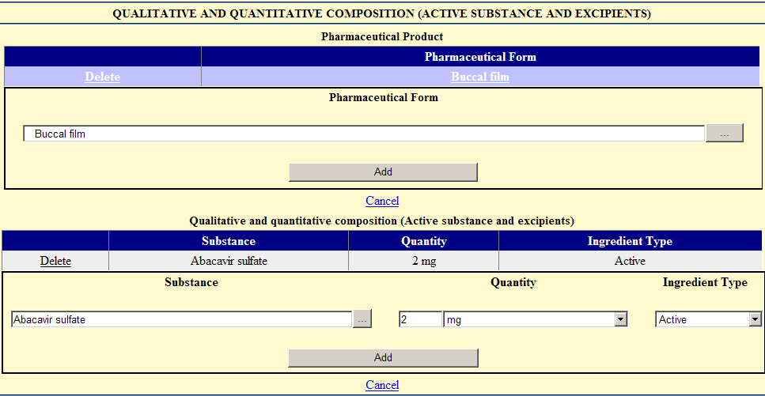

In the area Pharmaceutical Product it is necessary to fill the field "Pharmaceutical Form" (as many times as applicable).

In the Qualitative and quantitative composition (Active substance and excipients) area is necessary to indicate the composition applicable to each pharmaceutical product. It is necessary to enter information relating to all active substances and excipients, included in pharmaceutical product, filling in the fields: “Substance”, “Quantity” (including units) and “Ingredient Type”.

The filling of these fields is described in sections below.

4.6.1 Pharmaceutical Product

Selection list content:
* The pharmaceutical form should be indicated from the"STANDARDS TERMS - Pharmaceutical dosage forms" - European Pharmacopoeia.

Filling in:
(selection field)

* Whenever possible it should be selected the same pharmaceutical form as was indicated in the “Pharmaceutical Form” on “Marketing Authorisation Application Details” area.

* When the medicine has a combined pharmaceutical form, the composition of each pharmaceutical product should be inserted.
E.g.: powder and solvent for solution for injection should be separated into two pharmaceutical products - “powder for solution for injection” and “solvent for parenteral use”

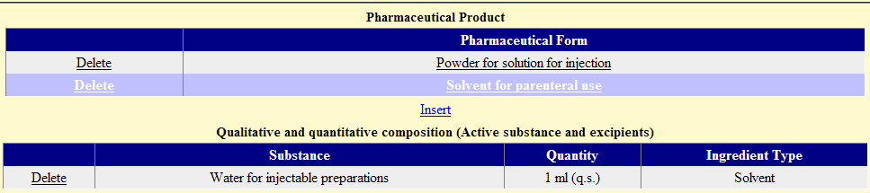

Searching and filling in:
(selection field)

* Click the key and afterwards. In the new window write the pharmaceutical form and click .

* From the resulting list select the intended Pharmaceutical Product by clicking the corresponding name.
* Click to insert the Pharmaceutical Product in the main window.

* To cancel inserting the Pharmaceutical Product click .

* To remove a Pharmaceutical Product inserted click .

4.6.2 Qualitative and quantitative composition (Active substance and excipients)

ATTENTION:
- To fill the Qualitative and quantitative composition (Active substance and excipients) you must first select the correspondent Pharmaceutical Product line (that will appear shared in violet). A selection is made by clicking on the Pharmaceutical Form (underlined in the main window of the Pharmaceutical Product).

- The main window shows information inserted for the selected Pharmaceutical Form. Selecting another Pharmaceutical Form will show the information inserted for the newly selected Pharmaceutical Form.

4.6.2.1 Substance

Filling in:
(selection field)

* Select the key and click afterwards in the Substance field. In the new window write the name of the substance and click .

* From the resulting list select the intended Substance by clicking on the corresponding line.

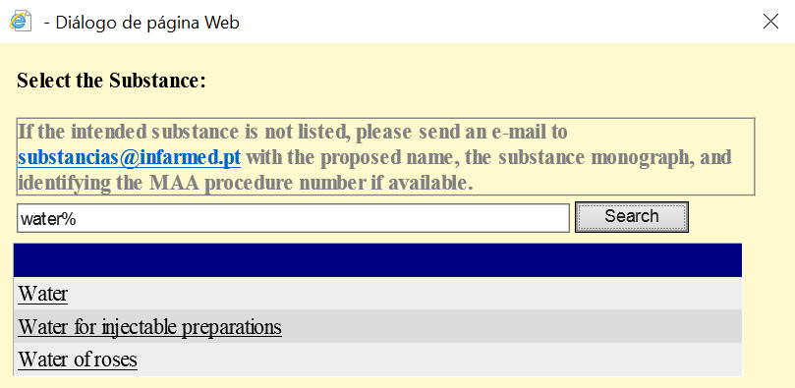

* The substance is shown in the main window.

Note: search should be as equal as possible to the name of the substance.
E.g.: If you want to search for magnesium stearate, search for stearate.

ATTENTION: If the intended substance is not found on the list, ask Infarmed to include it via email dam@infarmed.pt, along with the monograph of the substance and identifying the MAA.

4.6.2.2 Quantity and Units

Use:
* Quantitative description of the components in pharmaceutical form.
* Select substances as they are present within the formula (e.g. salt or hydrate).
* Choose N.D if the substance is not present in the final product, e.g.: substances inserted with “Reagent” in the “Ingredient Type”.
* Overages are not included in the loading of the active substance.
* For radionuclides the unit to be used is Becquerel.
* In case of vaccines, active substances should be mentioned in biologic units.
* For pH, if the value is mentioned, insert the number (e.g.: 3) and choose pH (q.b.p.).
* You should avoid using %.

Filling in:
(numeric field / selection field)

* In the field “Quantity”, ALWAYS write the numeric quantity of the substance (use dots and never commas).

* Do not place zeros after the last number (e.g.: 10.02 mg instead of 10.020 mg)

* The Units field is a pre-defined units list, so the selection is made from the available list.

E.g.: Quantity of a given substance = 15.3 mg
Quantity – 15.3 (correct) Quantity – 15,3 (incorrect) Quantity – 15.30 (incorrect)
Units - mg Units – mg Units - mg

E.g.: Quntity of a given substance = q.b.p 1 ml
Quantity – 1
Units – ml (q.b.p.)

Filling the field Qualitative and quantitative composition (Active substance and excipients) (Quantity and Units) according to the different pharmaceutical forms

 | Composition
Single-dose solid pharmaceutical forms  Capsule, Tablet, Lozenge, Cachet; Suppository  (blister; strip; Sachet; Tablet container etc.) | Substance quantity – mass  20 mg
Multi-dose solid pharmaceutical forms  Granules  (in bottle) | Substance concentration – mass/total mass  50 mg/g
Singe-dose liquid pharmaceutical forms  Eye drops, solution, solution for injection, oral solution  (ampoule, sachet, vial) | Substance concentration– mass/total volume  5 mg/ml
Multi-dose liquid pharmaceutical forms  Syrup, Oral solution, eye drops, solution  (in bottle) | Substance concentration – mass/total volume  500 mg/ml
Single-dose semi-solid pharmaceutcal forms  Cream, paste, ointment, gel  (cannula, tube) | Substance concentration – mass/total mass  5 mg/g
Multi-dose semi-solid pharmaceutical forms  Cream, paste, ointment, gel  (cannula, tube) | Substance concentration– mass/total mass  50 mg/g
Concentrates  Concentrate for solution for injection | Substance concentration before dilution – mg/ml  20 mg/ml
Impregnated dressing, implanter, Intrauterine delivery system and Transdermal system | Preferred -> substance quantity in each dressing – mass  50 mg
Aerosol | Preferred -> Follow the rules for the pharmaceutical form as if it weren´t for inalation (e.g.: powder or solution for inhalation – mass  250 µg

Powders for reconstitution
Includes also powders and solvents. In this last case two lines will have to be inserted, one related with the powder composition and another related with the solvent composition.

Powder – quantity of each substance inside the primary packaging (as for sachets)
Solvent – quantity of each substance and solvent as“q.b.p. x ml” (reconstitution volume).

Single-dose powders for reconstitution  - With reconstitution volume  - Without reconstitution volume | Active substance concentration – mass : total volume  Powder - 500 mg  Solvent - 10 ml = total volume  Active substance quantity - mass  Powder – mg
Pós para reconstituição (multidose)  - With reconstitution volume  - Without reconstitution volume | Active substance concentration – mass : total volume  5 mg  Active substance concentration – mass/mass  50 mg/g

4.6.2.3 Ingredient Type

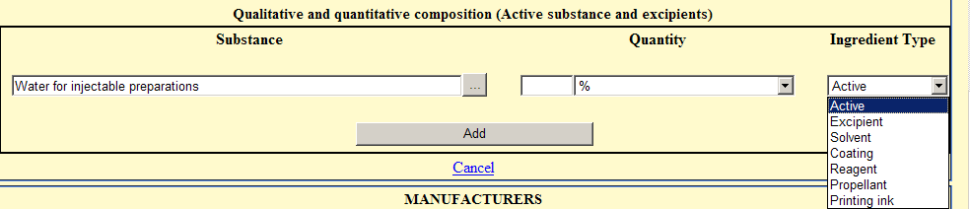

Use:
* Classification of Pharmaceutical Form components with respect to their function in the formulation.

Components of the medicine:
- Active substances; excipients and coating components (e.g.: capsules)
- Filling gases used in ampoules, aerosol propelants and others

* In respect to sets of radiopharmaceuticals (kits), which should be radiolabeled after being provided by the manufacturer, consider the active substance as the component of the formulation intended to carry or bind the radionuclide.

* For generators, both original radionuclides and its degradation products should be considered active substances.

Filling in:
(selection field)

* The options listed below and their respective definitions should be taken into account:

Ingredient Type (EN) | Definition (when to use)
Excipient | Any component whose function is not described in the options listed below.
Coating | Any component that integrates coating mixtures and / or capsules.
Printing ink | Any component that integrates printing ink.
Solvent | Any component that integrates the solvent / vehicle presented in a separate container, but forming part of the product.
Reagent | Any component used in the manufacturing process and which is not present in final dosage form.
Propellant | Gas under pressure.

ATTENTION: After filling the row corresponding to each ingredient it is necessary to click to include the substance in the composition.

* To cancel inserting the Composition click .

* The inserted Sunstance can be removed afterwards using the key .

4.7 Manufacturing Chain

In this area the applicant can fill in the information concerning the manufacturing flowchart of the medicinal product.

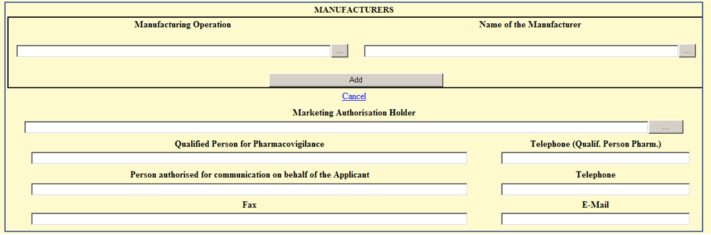

This area consists of the following fields / subfields:

• Manufactures
• Marketing Authorisation Holder
• Qualified Person for Pharmacovigilance
• Telephone (Qualif. Person Pharm.)
• Person authorised for communication on behalf of the Applicant
• Telephone (Person authorised for communication on behalf of the Applicant)
• Fax (Person authorised for communication on behalf of the Applicant)
• Email (Person authorised for communication on behalf of the Applicant)

4.7.1 Manufactures

In the subarea Manufacturers it is necessary to enter in the field "Name of the Manufacturer” the manufacturer(s) involved in the manufacturing of the medicinal product, and in the field "Manufacturing Operation” the respective functions performed.

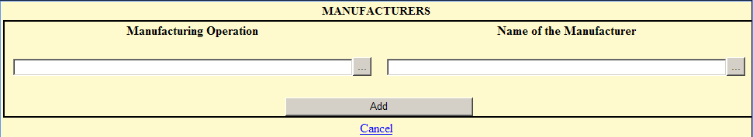

General concepts:

* For all medicinal products the following manufacturing operations and respetive manufacturer’s name must ALWAYS be included is: Bulk Manufacturer, Immediate Packaging, Outer Packaging, Manufacturer of the Active Substance, Responsible for Batch Release and Batch Control/Testing Site.

* When the same manufacturer is responsible for more than one step/manufacturing operation, the name of the manufacturer should be repeted for each operation.

* One medicine may have more than one manufacturer for each manufacturing operation. Each and every manufacturer should be inserted.

4.7.1.1 Manufacturing Operation

List content and filling in instructions:

Manufacturing Operation (EN) | Definition (when to use)
Required Manufacturing Operation
Manufacturer of the Ative Substance | Manufacturer responsible for synthesis/obtention process the  active substance (all phases of the process or only final phases, including micronization).
Bulk Manufacturer | Manufacturer responsible for intermediate phases (non‐final) of the manufacturing process of the bulk product.
Immediate packaging | Manufacturer responsible primary packaging.
Outer packaging | Manufacturer responsible for secondary packaging.
Responsible for Batch Release | Manufacturer responsible for batch release in the European  Economic Area.
Batch control/Testing site | Manufacturer responsible for quality control/in‐process control of the active substance.
Optional Manufacturing Operation
(should only be added if referred in AIM dossier)

Contact Company used for Bioavailability or Bioequivalence Trials | Wherever applicable / specified. Include the sponsor of the study, the company responsible for the clinical phase of the study and the company responsible for the analytical phase of the study.
Contact Company used for Validation of Blood Product Manufacturing Processes | Where applicable.
Manufacturer of intermediate compound of ative substance | Manufacturer responsible for synthesis/obtention process the  intermediate compound of active substance.
Batch control/Testing site of ative substance | Manufacturer responsible for quality control/in‐process control of the active substance.
Sterilization | Manufacturer responsible for one sterilisation stage only.
Intermediate Stage Manufacturer | Manufacturer responsible for intermediate phases (non‐final) of the manufacturing process of the bulk product.
Package material supplier | Packaging material supplier/manufacturer.
Responsible for batch release of ative substance | Manufacturer responsible for batch release of active substance.
Medical devices supplier | Medical devices supplier/manufacturer.
Labelling | Manufacturer responsible for immediate packaging labelling.
Manufacturer of excipient | Excipient supplier/manufacturer.
Manufacturer of solvent | Manufacturer responsible for manufacturing the solvent/vehicle  in a separate container but being part of the medicinal product.

Searching and filling in:
(selection field)
* Select the key and afterwards. In the new window write the Manufacturing Operation and click .

* From the resulting list select the intended Manufacturing Operation by clicking on the corresponding line.

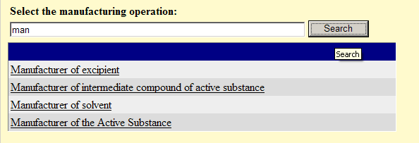

* The Manufacturing Operation is shown in the main window.

ATTENTION: When selecting the manufacturer of the active substance it is necessary to select the" Manufactured Substance" from the selection list containing the active substances introduced in the area " Qualitative and quantitative composition (active substance and excipients)”. So FIRST it should ALWAYS be inserted and added the active substance in the area " Qualitative and quantitative composition (Active substance and excipients)".

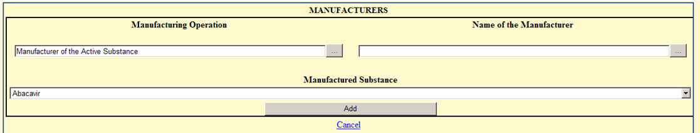

4.7.1.2 Manufacturer (name and address)

Use:
* It should be selected the name and address of the Manufacturer associated with the selected Manufacturing Operation.

Searching anf filling in:
(selection field)

* Select the key (if the Manufacturing Operation hasn´t been inserted yet) and click afterwards. In the new window write the name of the manufacturer and click .

* Select the intended manufacturer/address from the resulting list, by clicking the corresponding line.

Note: search should be as exact as possible.
e.g.: if a manufacturer has Laboratory in the name do not use Lab.

ATTENTION: Whenever an address concerns a manufacturer and there is the same name and address in two different options, choose the one with (Fab. xxxxx) after the name since these concern manufacturing site addresses.
Allways check if the name/address is the one intended. There may be very similar names/addresses in the list.

* The manufacturer is shown in the main window. Click .

* To cancel inserting the manufacturer click .

* The inserted manufacturer can be removed afterwards using the key .

ATTENTION: If the intended entity is not found on the list, send a request to Infarmed via email entidades@infarmed.pt, to include it in the list, along with relevant documentation and identifying the MAA. If the entity required is a manufacturer one of the following three documents must be submitted: Certificate of GMP, CEP or Manufacturing Authorisation. If the requested entity is a future marketing authorisation holder it is necessary to attach copy of Company Register Information.

4.7.2 Marketing Authorisation Holder
(Selection field)

Use:
* It should be selected the intended MA holder from the available list.

Searching anf filling in:
(selection field)

ATTENTION: Do NOT choose addresses containing the expression …(Fab ….) as these concern manufacturing site addresses.

* Click the key . In the new window write the name of the MAA holder and click .

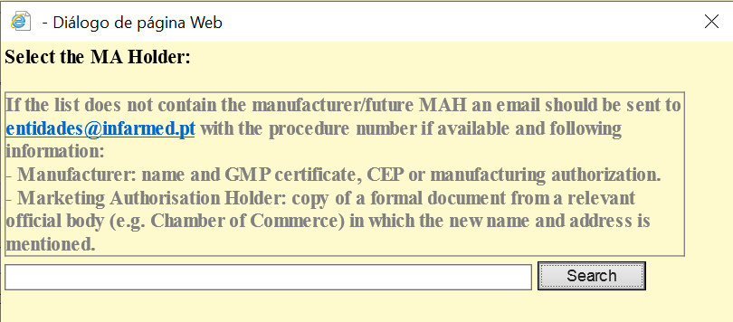

* Select the intended MAA from the resulting list of search, by clicking on the corresponding line.

* The MAA name / address is shown in the main window.

ATTENTION: If the intended entity is not found on the list, send a request to Infarmed via email entidades@infarmed.pt, to include it in the list, along with relevant documentation and identifying the MAA. If the entity required is a manufacturer one of the following three documents must be submitted: Certificate of GMP, CEP or Manufacturing Authorisation. If the requested entity is a future marketing authorisation holder it is necessary to attach copy of Company Register Information.

4.7.3 Qualified Person for Pharmacovigilance and Person authorised for communication on behalf of the Applicant

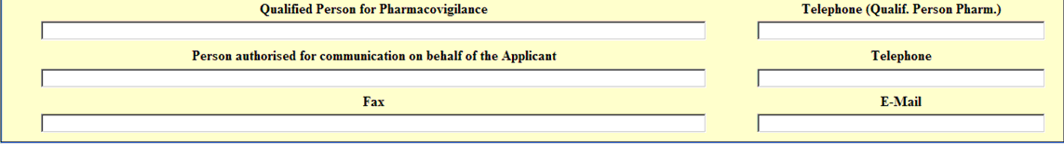

4.7.3.1 Qualified Person for Pharmacovigilance and Telephone (Qualif. Person Pharm.)
(text field /numeric field)

Fill in with the Qualified Person for Pharmacovigilance (EU-QPPV) name and telephone.

4.7.3.2 Person authorised for communication on behalf of the Applicant (Name, Telephone, Fax and Email)
(text field / numeric field)

Fill in with the name, telephone, fax and email of Person authorised for communication on behalf of the Applicant.

ATTENTION:
- It is mandatory the inclusion of the name, telephone, fax and email address of the person authorized for communication on behalf of the applicant during the evaluation process.
- The email address of the contact person indicated in this field should always be referred in the "Declaration form for the use of email communications with INFARMED" attached in the Documents area and should be consistent with the email address of the contact person as indicated in original application form to be submitted to Infarmed.

4.8 documents Attachement Area

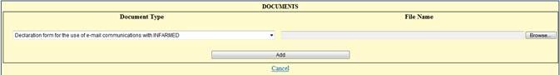

In this area the applicant must enclose the document “Declaration form for the use of email communications with INFARMED". The template made available by Infarmed should be used.

Additionally, it will be necessary to attach a "Proof of payment of fee", if the marketing authorisation application concerns a mutual recognition procedure (with Portugal as RMS), and for which the applicant has payed the fee for application for marketing authorization by national procedure with a view to subsequent application for MR.

* Click the button and "Browse” afterwards.

* Select the inteded document and the path to the file location will appear in the field box. After clicking the file is attached to the form.

* To cancel inserting the document click .

* The inserted document can be removed afterwards using the key .

The document should be in PDF format and it should not exceed 500 kb. Compress the file if the 500 kb limit is exceeded.

4.9 Statement regarding risk of transmission of spongiform encephalopathies
(selection field)

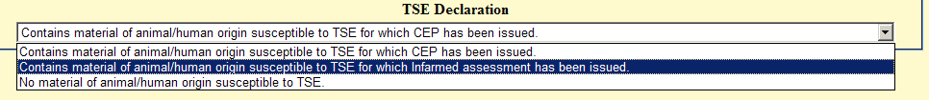

* Identification of Annex classification of the medicine in regardind to the Transmission of Animal Spongiform Encephalopathies.

List content:

* The options are
- Contains material of animal/human origin susceptible to TSE for which CEP has been issued (Annex 1);
- Contains material of animal/human origin susceptible to TSE for which Infarmed assessment has been issued (Annex 2);
- No material of animal/human origin susceptible to TSE (Annex 3).

Raw material | Documents | Annex
 | with TSE_CertiPhEur | 1
With risk
 | one substance without TSE_CertiPhEur | 2
without risk |  | 3

A medicine is classified in annex 3 when either its composition, manufacturing of excipientes, manufacturing of active substances, reagents and culture media do not have any specific risk material.

When there are materials with risk in either composition, manufacturing of excipientes, manufacturing of active substances, reagents and culture media:
1) If there is at least one risk material without a certificate of the european pharmacopeia, annex 2 is applicable.

2) If all risk materials have a certificate of the european pharmacopoeia, annex 1 is applicable.

4.10 Action Buttons: Save and back

In this area the applicant can save changes made to the online application form using the button or return to the Initial screen using the button

To save the information in the application form it is necessary to fill in the following minimum information:

- “Pharmaceutical Form” in “Marketing Authorisation Application Details” area.

- “Proposed (Invented) Name” in “Marketing Authorisation Application Details” area.

- “Strength” in “Marketing Authorisation Application Details” area.

- “INN / Active Substance” in “Marketing Authorisation Application details” area.

- “Marketing Authorisation Holder” in “Marketing Authorisation application Details” area.

- “Select the Reference Medicinal Product” in “Application Type” area, when available.

- “Procedure Number” in “Procedure Information” area, when available.

- “Person Authorised for Communication on behalf of the applicant” in “Manufacturers” area.

- “Telephone” (Person Authorised for Communication on behalf of the applicant) in “Manufacturers” area.

- “Fax” (Person Authorised for Communication on behalf of the applicant) in “Manufacturers” area.

- “Email” (Person Authorised for Communication on behalf of the applicant) in “Manufacturers” area.

- “RMS” in “Procedure Information” area.

If those required fields are not filled in, a message will be displayed with the respective information that the field is mandatory.

After filling in the required fields the aplication can be successfully saved the first time. After the first saving operation it is possible successive save the changes made to the form as it is being filled.

ATTENTION:
- If the button is pressed before the button the information entered will be lost.

- During the filling and after pressing the button the "Status" of the application is "Filling in progress".

- The form can be saved and changed until issue of the payment form. Additional changes to the form are not allowed once a payment form has been issued (unless the payment form generated is subsequently cancelled, which is only possible before issue the payment reference and if no payment has been validated).

5. Copy an Application

In case of submission of more than one strength or pharmaceutical form, or even in case of duplicate applications, it is possible to copy an electronic form previously completed.

To copy an application click the link  placed in the last but one column of the search result area in the initial screen.

In the new electronic form available after clicking it is necessary to change the information that differs from the original copied application. After clicking a new application will be created with the satus “Filling in progress”. The new application is identified by the introduction of “(copy)” in the field “Proposed (Invented) Name”.

It will only be possible to copy applications filled in/submitted after the 21st of October 2013.

6. Delete an Application

ATTENTION: Only aplications in the status “Filling in progress” can be deleted. After issuing the payment form and payment validated is not possible to delete the application.

This function allows to delete an application.

* In case you need to delete an application already introduced in the system and in the status “Filling in progress”, select the link , placed in the search result area in the initial screen.

* The following message will appear “Are you sure that you want to delete this record?”, alerting that the selected record will be deleted from the system.

Be aware that once you delete the aplication, there is no turning back.

7. Change an Application Already Saved

ATTENTION: Only aplications in the status “Filling in progress” can be altered/corrected. After the issuing of the payment form and payment validated is not possible to change the application.

* In case you need to change an application already introduced in the system and in the status “Filling in progress”, the application can be selected using the links in the columns headed “Procedure Number” or “Medicinal Product Name”, placed in the search result area in the initial screen.

* The application form will be displayed and changes/corrections can be introduced.
* To save the inserting changes click .

8. Submitting Marketing Authorization Applications

To perform the pre-submission of applications in the system, it is necessary to select the online forms from the search result area of the initial screen, and issue the payment form by selecting the button . The payment form can only be issued for application forms that have been validated using the button , therefore the selection box will only be available for online forms for which validation of the online filling has been successful. If additional changes are made and saved to previously validated form, the selection check-box will on be available again after pressing again the button .

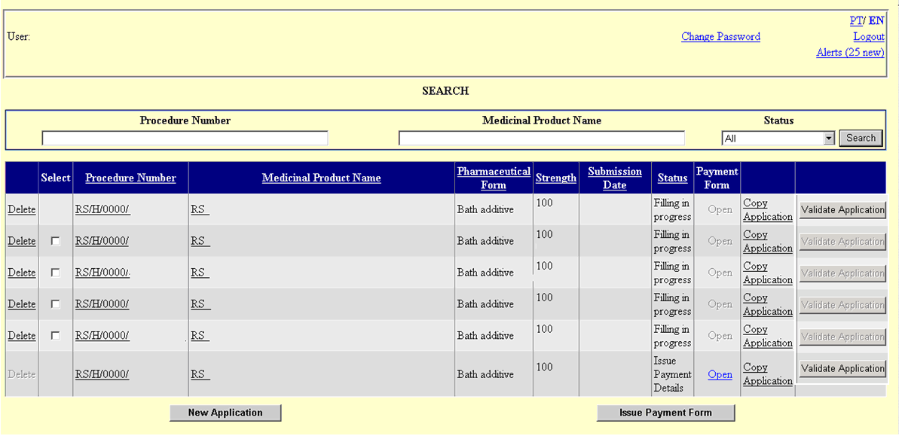

8.1 Issue the payment form for new applications

The payment form issued will inform the applicable of the fee value applicable to the MAAs being submitted, according to national legislation Portaria nº 377/2005, of 4th of April, which establishes the costs of the acts related with the application submitted to Infarmed.
The payment form is automatically generated based in the information contained in the online forms selected to be included in the payment form, therefore applicants are advised to carefully fill in the online forms .

To issue the payment form the following actions are required:

* Search the MAAs using the search area of the Inital Screen.

* Select the button for each of the online forms that will be included in the same Payment Form.
The following information as filled in the in the online forms will be validated:

- In case at least one record has not been inserted in the subarea “ATC Classification” of the “Application Characterization Area” the following message will be displayed: “ATC code is missing”.

- In case at least one record has not been inserted in the subarea “CFT Classification” of the “Application Characterization Area” the following message will be displayed: “CFT code is missing”.

- In case at least one record has not been inserted in the subarea “Routes of Administration” of the “Application Characterization Area” the following message will be displayed: “Route of Administration is missing”.

- In case at least one record has not been inserted in the subarea “Container” with the respective shelf-life inserted in the subarea “Shelf life” of the “Container Area” the following message will be displayed: “Container/shelf-life is missing”.

- In case at least one record has not been inserted in the subarea “Pharmaceutical Product” with the respective ingredients including the substance “Active” in the subarea “Qualitative and quantitative composition (Active substance and excipients)” of the “Qualitative and quantitative composition (Active substance and excipients) Area” the following message will be displayed: ““Active Substance is missing”.

- In case at least one record has not been inserted in the subarea “Manufacturers” of the “Manufacturers Area” the following message will be displayed: “Manufacturers are missing”.

- In case at least one entity has not been associated with each one of the following manufacturing operations, Manufacturer of the Active substance, Bulk Manufacturer, Immediate Packaging, Outer Packaging, Batch control/Testing Site, and Responsible for Batch Release in the subarea “Manufacturers” of the “Manufacturers Area”, the following message will be displayed: “Required Manufacturers are missing”.

- In case the documents “Declaration form for the use of e-mail communications with INFARMED” or “Proof of payment of fee” (if applicable) have not been inserted in the subarea “Documents Attachement Area ” of the “Documents Area”, the following message will be displayed: “Declaration form for the use of e-mail communications with INFARMED" / Proof of payment ” (when applicable) is missing.

- In case at least one shelf-life assotiated with the the container status “Closed”, has not been inserted for all packages in the subarea “Shelf life” of the “Container Area”, the following message will be displayed: “Shelf-life for the closed container is missing”.

- In case more than one shelf-life assotiated with the the container status “closed”, is inserted for one package included in the subarea “Shelf life” of the “Container Area”, the following message will be displayed: “More than one shelf-life for the closed container has been inserted”.

- In case at least on substance has not been assotiated with all the pharmaceutical products included in “Qualitative and quantitative composition (Active substance and excipients) Area”, the following message will be displayed “Pharmaceutical Product must include a substance”.

- In case Portugal has not been included in either the “RMS” or “CMS” fields of the “Procedure Information Area”, as applicable, the following message will be displayed: “Portugal must be selected as RMS or CMS”.

- In case any country has not been included in the “CMS” field of the “Procedure Information Area”, the following message will be displayed: “The field CMS is mandatory”.

* After the correct filling of these mandatory fields the application may be selected to issue the payment form (the checkbox, , in the column headed "Select" becomes available for selection).

* Under the column headed "Select", select the checkboxes of the online forms concerning the same MAA.

ATTENTION:
- In the payment form to be automatically generated the reduced fees applicable to supplementary strengths/pharmaceutical forms included in the same application will only be considered, if all the online forms concerning same marketing authorisation application are selected as described above to issue the payment form.

- Only the medicinal products concerning strengths/pharmaceutical forms belonging to the same MAA should be selected for inclusion in the same payment form.

- Duplicate applications should not be selected for inclusion in the same payment form.

Issuing of a joint payment form is only allowed if the following fields in the screen "New Application" are the SAME in all selected online forms:

- "Proposed (Invented) Name" of the "Marketing Authorisation Application Details Area";

- "INN / Active Substance" of the "Marketing Authorisation Application Details Area";

- "Application Type" of the "Application Type Area”;

- "Line Extension" of the "Application Type Area";

- "National procedure includes fee for subsequent MRP" of the "Procedure Information Area".

If the online forms selected do not fulfil the conditions needed to allow the inclusion in the same payment form, the following message wil be displayed: “It is not possible to issue a common payment form for the applications selected”.

* Select the button to issue the payment form.

* The payment form screen will be displayed:

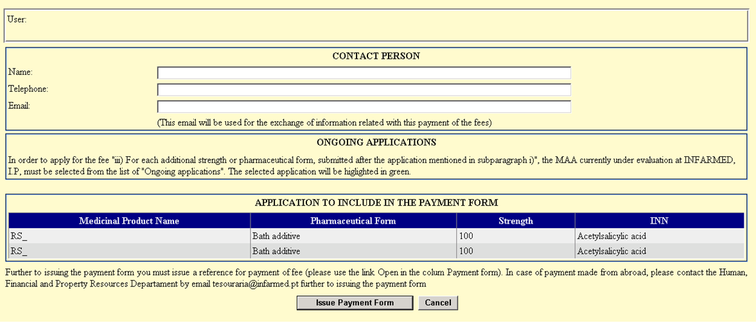

This screen is divided in the following areas:

Applicant’s Area
In this area the applicant can view the applicant’s name, corresponding to the user logged on to the Portal.
Contact Person Area
The applicant should fill in the contact details of the applicant’s contact person who should receive the information regarding the payment of the fee, namely in what concerns the receipt of automatic alertas sent by email. It is composed of the following mandatory fields:
- Name
- Telephone
- Email (used to send information regarding the payment of fees)

Ongoing Applications Area
This area will display the applicant´s applications under assessment by Infarmed with the same INN as one of the applications included in the payment form.

Applications to include in the Payment Form Area
This area displays the name/strength/pharmaceutical form/INN of the medicinal products concerned in the online forms selected and which will be included in the same payment form.

Action Area
In this are the applicant may:
- Proceed with the issuing of the payment form, by pressing the button ;
- Return to the previous screen, by pressing the button .

* After filling all mandatory fields in the Contact Person area (Name, Telephone and Email), click the button .

* After issuing the payment form, the status of the applications included in the payment form is changed to “Issue Payment Details” and the link in the column headed “Payment Form” becomes available in the Search Result Area in the Inicial Screen.

ATTENTION: As stated in the screen further to issuing the payment form the applicant must issue a reference for payment, as described in section 8.3.

8.2 Issue the payment form for strengths or pharmaceutical forms submitted afterwards

To apply for the fee “iii) For each additional strength or pharmaceutical form, submitted after the application, mentioned in subparagraph i)” the applicant should proceed as described below:

* Proceed initially as described in 8.1 Issue the payment form for new applications.

* In the screen used to issue the payment form, the area Ongoing Applications Area will display the applicant´s applications under assessment with the same INN as the applications selected to be included in the payment form. In order to apply for the reduced fee iii), the MAA currently under evaluation must be selected from the list of “ongoing applications”. The selected application will be highlighted in green.
* After filling the mandatory fields in the Contact Person Area (Name, Telephone, Email), click the button .

After issuing the Payment Form, the status of the applications included in the payment form is changed to “Issue Payment Details” and the link in the column headed “Payment Form” becomes available in the Search Result Area in the Inicial Screen.

ATTENTION: As stated in the screen further to issuing the payment form the applicant must issue a reference for payment, as described in section 8.3.

8.3 Issue payment for reference and Paying the Fee

To pay the fee the applicant has to access the “Payment Form Visualization Screen” and issue the reference for payment.

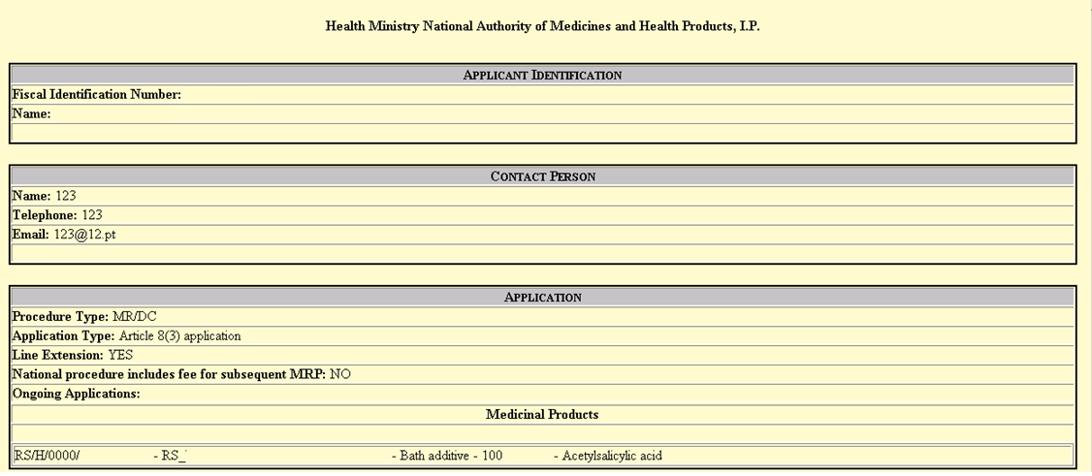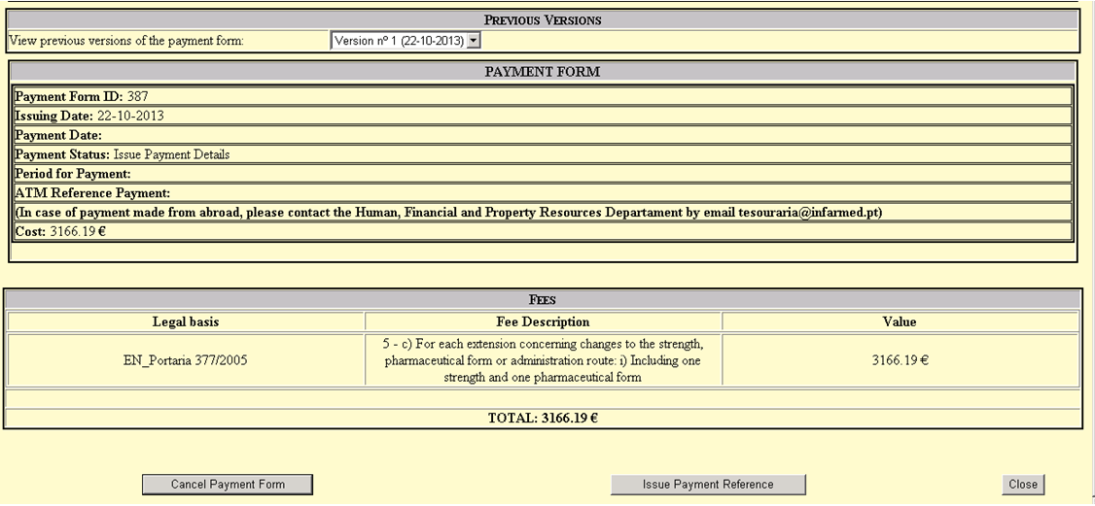

Payment Form Visualization Screen
This screen allows the applicant to see the payment form and can be accessed by clicking the link in the column headed “Payment Form” of the Search Result Area Inicial Screen.

For the applicant to be able to see the payment form the selected application must be in a status different from “Filling in progress”

This screen is divided in the following areas:

Applicant Identification Area
This area contains the information of the applicant that issued the payment form.

Contact Person Area
This area contains the information of the contact person as indicated by the applicant when creating the payment form

Application Information Area
This area contains the information regarding the application, according to information indicated in the online forms.

Area of Previous Versions
This area displays the field , and it provides access to previous versions of the payment form.
New versions of the payment form are issued when Infarmed corrects the payment form submitted. By selecting a value from the list the information regarding the version of the payment form is displayed.

Payment Form Information Area
This area contains the information regarding the payment details assotiated with the Payment Form

Area of Applicable Fees
This area contains the list of fee paragraphs that were applied in the payment form along with the total fee value for the application.

Action Area
In this area the aplicant is able to:
- Cancel the payment form, by clicking the button . After deleting the Payment Form the status of all the applications included in the Payment Form will be changed to “Filling in progress” and the payment form is deleted. This button is available if the status of all the apllications included in the payment form is “Issue Payment Details” or ““Missing payment of fee” , and the Payment Form does not have any payment already validated.

- Issue the reference for payment by clicking the button . This button is available only if the status of all the applications included in the payment form is “Issue Payment Details” or “Missing payment of fee” , and the Payment Form does not have any payment already validated.

- Close the Payment Form Visualization Screen by clicking the button .

ATTENTION:
- The fee value is calculated according to automatic rules based in the information introduced by the applicat in the online form. If it is detected that the fee value is incorrect, it is possible to delete the payment form by clicking the button .

- After issuing the reference for payment it will not be possible to cancel the payment form or make any corrections to the online form. In case it is necessary to correct the payment form, this is only possible before issuing the reference for payment.
- In case it is necessary to correct the payment form after validation of the payment, the applicant should contact DAM to the emails aim.nacional@infarmed.pt (national procedure), cms.procedures@infarmed.pt (DCP/MRP with PT-CMS) ou rms.procedures@infarmed.pt (MRP/DCP with PT-RMS), to ask for the corrections that may be eventually needed.

To issue the reference for payment the following steps apply:

* Search the MAA for which there is an intention to pay the fee in the Search Area of the Initial Screen,

* To see the Payment Form click the link in the column headed “Payment Form” of the Search Result Area in the Inicial Screen.

* Confirm if the fee value displayed in the Payment Form Visualization Screen is correct. If it is not correct, delete the payment using the button and if applicable correct the application form.

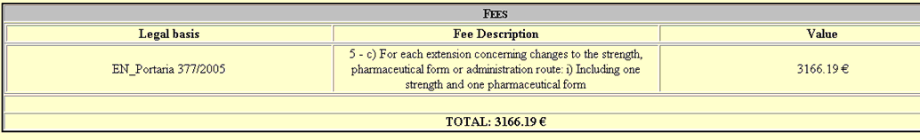

* To issue the reference for payment of the fee value, click the button .

* The following message will appear “Are you sure that you want to issue a reference for payment?”.

* After issuing the reference for payment, the status of the applications included in the payment form are changed to “Awaits payment” and the payment details are displayed in the Payment Form Information Area, namely:

- Entity
- ATM Reference Payment
- Period for payment
- Cost (amount to be payed)

Note: this information is also sent by email to the contact person mentioned in the “Contact Person Area” and can be viewed in the alerts screen.

Payments made from national territory:

* Applicants performing payments from national territory must pay the applicable fee using the payment details issued for Payment by ATM Reference (Entity/Reference/Cost/Period for Payment). It is not possible to perform payment outside of the period for payment indicated.

* After the payment and the correct reconciliation of the payment performed automatically by Infarmed´s Payment Gateway, the status of the applications included in the payment form are changed to “Payment of fee valid”.

* If the period for payment expires without payment of the fee or without payment reconciliation by Infarmed´s Payment Gateway, the status of the applications included in the payment form are changed to “Missing payment of fee”.

ATTENTION:
How to proceed in case of expiration of the ATM reference issued?
- If the Payment Form does not have any payment already validated, the applicat may issue a new reference for payment, as descrided above, or if applicable, cancel the payment form (see page 58) in case it is not correct.

- If the Payment Form already includes a validated payment, the applicat should ask DAM to issue a new reference for payment using the emails aim.nacional@infarmed.pt (national procedure), cms.procedures@infarmed.pt (DCP/MRP with PT-CMS) ou rms.procedures@infarmed.pt (MRP/DCP with PT-RMS),.

Payments made from abroad:

As the payment by ATM reference is a method for payment possible only in case of national payments, applicants making payments to Infarmed from abroad should proceed as follows:

* Reference for payment must be issued as descrided above.

* After issuing the reference, the applicant must contact the Human, Financial and Property Resources Departament using the email tesouraria@infarmed.pt for information on the alternative payment details. Payment for ID and reference for payment issued in association with the MAA being submitted should be indicated in the email.

The Human, Financial and Property Resources Departament will manually reconciliate the payments made from abroad, and once validated the status of the application in the portal will be changed to “Payment of fee valid”.

The MAA dossier should be formally submitted to Infarmed only after pre-submission of the application in SMUH-AIM and after validation of the fee payment (indicated in the portal by procedure status “Payment of fee valid”).

9. Screen for View of application

This screen allows the applicant to see the online forms submitted and can be accessed by pressing the fields/links “Procedure Number” or “Medicinal Product Name” available on the Initial Screen of the Search Result Area and the application status different from “Filling in progress”.

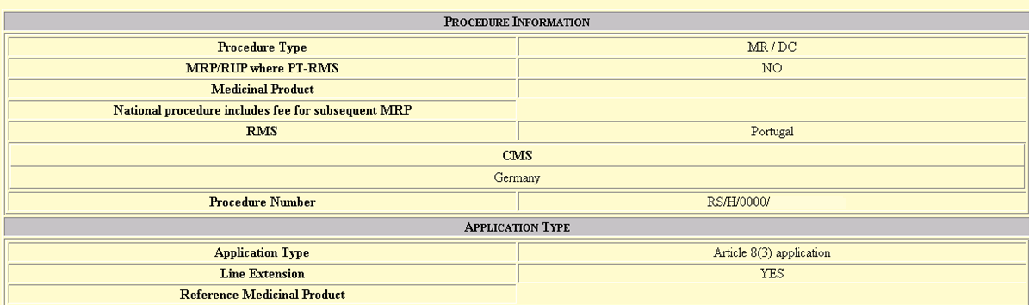
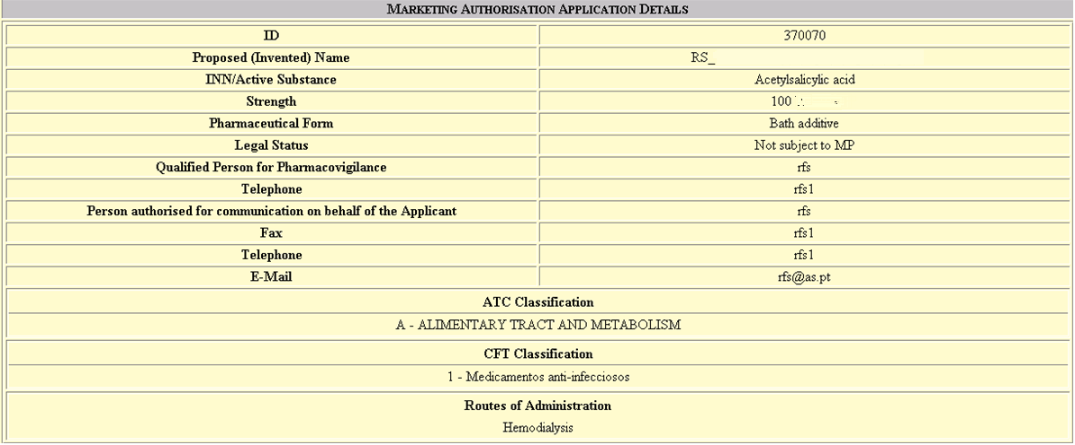
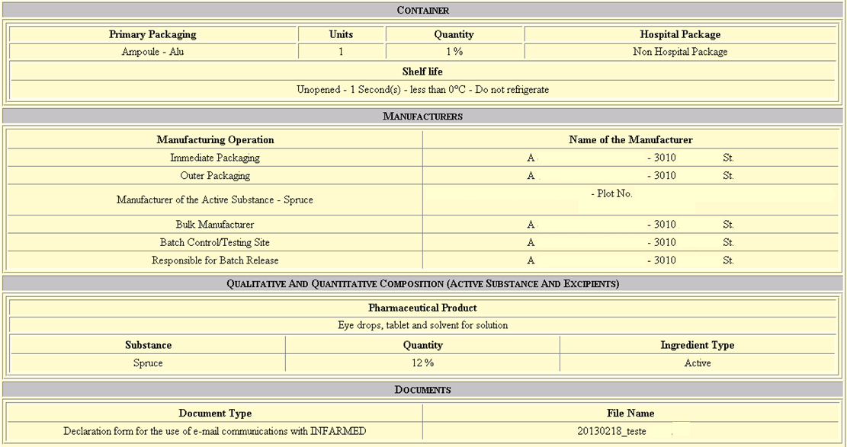

In this Area, the applicant can:

- Print the information of the application form by pressing the button;
- Save as HTML the information of the application form by pressing the button;
- Close the screen by pressing the button and return to the Initial screen.

All the information on this screen is available in Portuguese and English, being displayed in the language selected in the Initial Screen.

10. Request for supplementary information

This screen allows the applicant to view and respond to List of Questions made by the Procedure Manager, as well as to insert additional documentation to the procedure. This screen is accessed when the “Doc. submission” link is available in the “List of Questions” column on the Initial Screen of the Search Result Area.

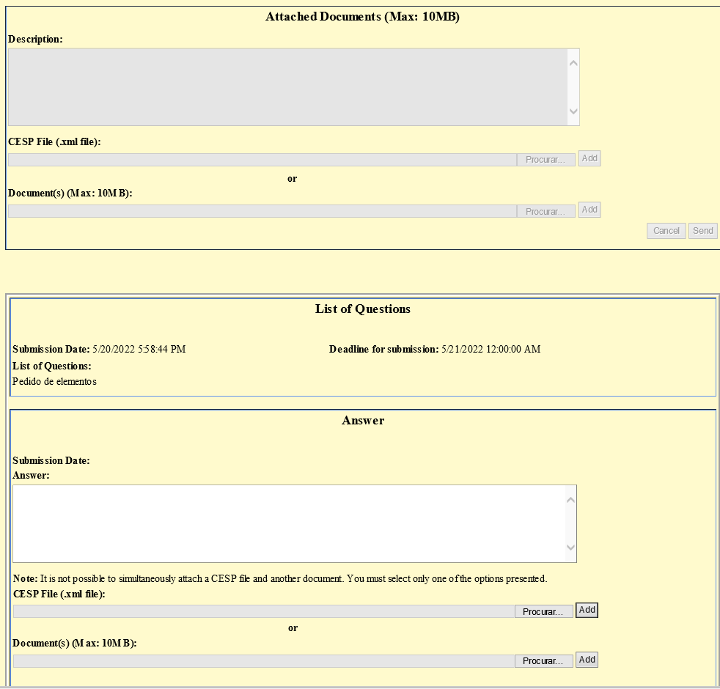

On this screen the applicant can:

• View all List of Questions made by the Procedure Manager, as well as the respective responses (if any), in the “List of Questions” and “Answer” areas;

• Answer to List of Questions that have yet to be answered, as well as attach documents to the response given, in the “Answer” area;

• Attach additional documentation to the procedure, in the “Attached Documents (Max: 10MB)” area;

• Close the screen using the “Cancel” button and return to the Initial screen.

All the information in this pop-up is available in Portuguese and English, being displayed in the language selected on the Initial Screen.

In order to submit a answer to a List of Questions, the applicant must:

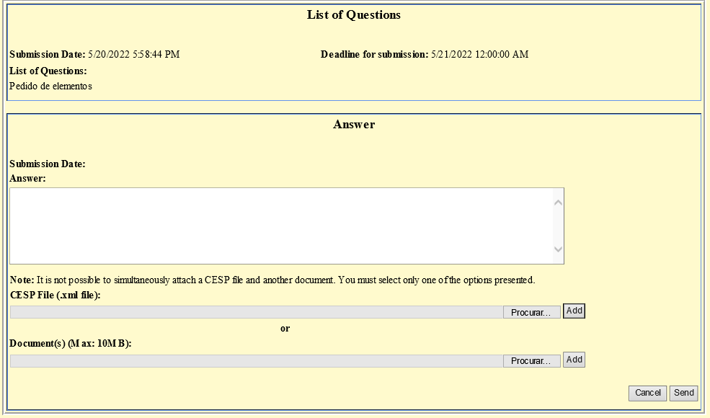

- Fill in the “Answer” field in the “Answer” area of ​​the respective List of Questions (text field - 1500 characters).

- Mandatory attach a document in the field “CESP file (.xml file)” or at least one document in the field “Document(s) (up to 10MB)”. To do so, you should start by clicking on the “Browse” button referring to the type of document you want, then select the document to be attached and finally click on the “Add” button.

NOTE: It is not possible to attach simultaneously a CESP file and another document, so the applicant must select only one of the options presented. It should also be noted that in the field “CESP file (.xml file)” it is only possible to attach a single file, unlike the field “Document(s) (up to 10MB)” in which it is possible to add several documents up to a total limit of 10MB.

- Select the “Send” button.

In order to submit additional documentation, the applicant must:
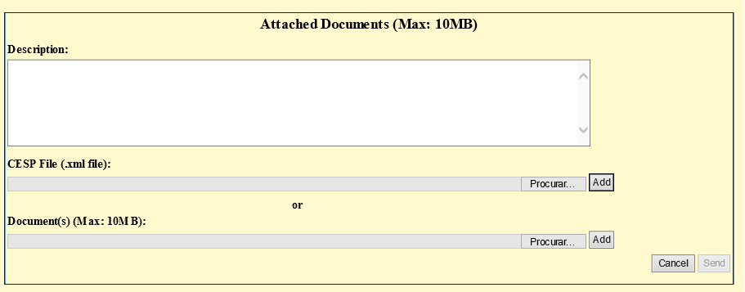

- In the “Attached Documents (Max: 10MB)” area, attach a document in the “CESP file (.xml file)” field or at least one document in the “Document(s) (up to 10MB)” field. To do so, you should start by clicking on the “Browse” button referring to the type of document you want, then select the document to be attached and finally click on the “Add” button.

NOTE: It is not possible to simultaneously attach a CESP file and another document, so the applicant must select only one of the options presented. It should also be noted that in the field “CESP file (.xml file)” it is only possible to attach a single file for each submission, unlike the field “Document(s) (up to 10MB)” in which it is possible to add several documents up to a total limit of 10MB.

- Fill in the “Description” field (text field - 1000 characters).
- Select the “Send” button.

11. Procedure details

This pop-up allows the applicant to view the details of the assessment carried out by the Procedure Manager and is accessed through the icon available in the “Procedure details” column on the Initial Screen of the Search Result Area.

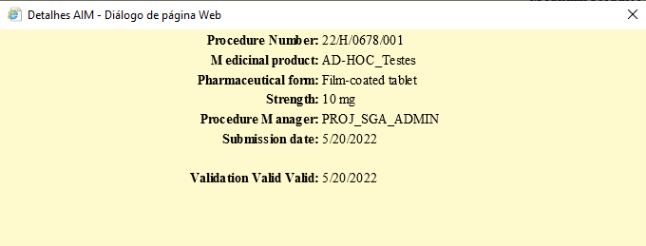

In this pop-up the applicant will be able to:

• View the details of the assessment carried out by the Procedure Manager;

• Close the pop-up and return to the Initial Screen.

All the information in this pop-up is available in Portuguese and English, being displayed in the language selected on the Initial Screen.

